 | Epsom & Ewell F.C.  v  Dorking F.C.  Tuesday 17th August 2010
For this evening’s League match we welcome Dorking F.C. today's officials, and of course our own regular supporters to Merstham F.C.

And what a place this is! I don’t know about everyone else, but I just had to walk about three yards into the ground to realise how much of an upgrade we now have on our previous “home” venue. The pitch is like a bowling green and the facilities wouldn’t look out of place if Merstham were a Conference South team. Of course, the weather was rubbish again, but we can hardly blame our new hosts for that one, and it’s also nice to know that I will be able to go to games without having to pack four spare layers of clothing!

I think it’s fair to say that our players enjoyed themselves on Saturday too, and produced a majestic performance in seeing off the threat of a very solid Sussex League team in Shoreham. We have as any regular supporter knows, been a passing team ever since Lyndon took over nearly four years ago. However, one problem that we have occasionally had is with work rate and tempo. However, Shoreham never got a chance to rest, being pressed the moment they had the ball. Well done chaps, if we can keep this up, we could have a very good season. We now meet our old friends from Flackwell Heath here on Saturday 28th August.

But back to tonights match. I’ll be honest, when I wrote the programme for our meeting back in April, I didn’t think we’d be seeing Dorking for a season or two, as they looked destined for relegation. However, reprieves are always nice for the club concerned, so just four months later they are visiting us again and setting a new club record in the process, as they become the first team to have played at all four of our Senior status grounds that we have called home.

Back then, we were confident of victory and understandably so. We were about to play a team at the foot of the table that had just been beaten 7-2 by the team just one place above them. However, their players produced a fine rearguard performance to frustrate us and the game ended as a goalless draw. I must also remind everyone that we haven’t actually beaten our visitors at home since recording a 3-0 win on 22nd of August 2000. Let’s hope we can snap that particular run tonight, just five days before it would reach the ten-year mark.

Enjoy the game!

Richard

Cover photo by Gemma Jarman

Mark Jarman scores our third goal against Shoreham
In our F.A.Cup tie on Saturday.

Cherry Red Records Combined Counties League
Premier Division Table
inc Saturday 14th August | P | W | D | L | F | A | Pts | GD
Mole Valley SCR | 2 | 2 | 0 | 0 | 8 | 2 | 6 | +6
Chertsey Town | 2 | 2 | 0 | 0 | 7 | 1 | 6 | +6
Sandhurst Town | 2 | 2 | 0 | 0 | 5 | 2 | 6 | +3
Molesey | 2 | 1 | 1 | 0 | 4 | 1 | 4 | +3
Guildford City | 2 | 1 | 1 | 0 | 5 | 3 | 4 | +2
Chessington & Hook | 2 | 1 | 1 | 0 | 3 | 2 | 4 | +1
Cove | 2 | 1 | 0 | 1 | 8 | 2 | 3 | +6
Epsom & Ewell | 2 | 1 | 0 | 1 | 4 | 3 | 3 | +1
Dorking | 1 | 1 | 0 | 0 | 1 | 0 | 3 | +1
Camberley Town | 2 | 1 | 0 | 1 | 4 | 4 | 3 | 0
Badshot Lea | 2 | 1 | 0 | 1 | 3 | 4 | 3 | -1
Croydon | 2 | 1 | 0 | 1 | 2 | 3 | 3 | -1
Ash United | 2 | 1 | 0 | 1 | 2 | 4 | 3 | -2
Banstead Athletic | 2 | 0 | 1 | 1 | 1 | 2 | 1 | -1
Colliers Wood Utd | 2 | 0 | 1 | 1 | 4 | 6 | 1 | -2
Bookham | 2 | 0 | 1 | 1 | 1 | 3 | 1 | -2
Horley Town | 2 | 0 | 1 | 1 | 1 | 5 | 1 | -4
Raynes Park Vale | 2 | 0 | 1 | 1 | 1 | 8 | 1 | -7
Hanworth Villa | 2 | 0 | 0 | 2 | 1 | 3 | 0 | -2
Egham Town | 1 | 0 | 0 | 1 | 1 | 4 | 0 | -3
Wembley | 2 | 0 | 0 | 2 | 1 | 5 | 0 | -4

Lucky Day? – 17th August
Played 7 - Won 4 Drawn 1 Lost 2 - F16 A7 - PPG 1.86 - Good

Club record against Dorking
Played 65 - Won 32 Drawn 10 Lost 23 - F139 A113 - PPG 1.63 - Above Average
Last Visit: - 12/04/10 - Drew 0-0 - Combined Counties League

From behind the goal
Epsom & Ewell 3-0 Shoreham F.C. – F.A.Cup Extra-Preliminary Round
Saturday 14th August 2010

Epsom & Ewell F.C. booked their place in the Preliminary Round of the F.A.Cup following a convincing 3-0 win over Shoreham.

It was of course the first home game at Merstham F.C. and 67 attended to see a great debut from the Blues. An unchanged line up from Wednesday's win at Croydon meant another place on the bench for regular custodian Paul Borg, but Neil Harrowing was totally in control of anything that came his way. Fortunately, this wasn't too much, largely due to a commanding display from our back four.

In fact this was really the difference between the two sides especially in the first half, as Epsom looked much more dangerous going forward, even though possession was fairly even. After ten minutes we were ahead. A free kick in the centre of the field from Tony Cuff was lofted to the back post where Mark Jarman was able to head the ball downwards and past the keeper from the edge of the six-yard area.

Just before the goal, and bizarrely in a torrential downpour, a wasp attacked me, but it was Shoreham who were stung into action by the goal and they pushed forward, providing our boys with a tough fifteen minutes. Gradually though Epsom got back into the match and a pass from Cuff set Darren Smith through on goal. I don't think he realised it at first, as he was looking across to pass it, but then realised that he was through on goal and as he got close he stroked the ball into the far corner in the 38th minute.

A little injury time was played in this half, and right at the end of it another free kick from Cuff was reached by Jarman, who got to the ball ahead of the keeper and helped it over him and into the net with a delightful touch (see front cover).

The second half started with a new keeper for the visitors, and a few minutes into the half Harrowing was called on to make a great save with his feet from a downward header. The Shoreham player was offside, but he wouldn't have known that at the time.

Shortly afterwards Cuff went into the book for the second straight game, but he was still having a major say in the match with his deliveries, which I am already struggling to find a historical comparison with. He nearly had a fourth assist after 59 minutes when he floated the ball onto Charlie West's head, but the big man glanced the chance wide.

Shoreham were rocking and moments later Smith made another great run down the right, and his square pass on the deck was perfect for Jarman, but the keeper made a great stop from point blank range, one he would repeat in the final minutes of the match after Jarman had carved out a similar chance for Joe Paris.

This was a great result against a decent team that had opened up their own League campaign with a draw and an away win, and in two weeks time we will be at home again in the next round to Flackwell Heath. Can't wait!

Recent Results and Remaining Fixtures
F.A.Cup – Friday 13th August
Mole Valley SCR | 0-5 | Chertsey Town
F.A.Cup – Saturday 14th August
Camberley Town | 2-1 | Petersfield Town
Chessington & Hook United | 1-2 | Raynes Park Vale
Cove | 1-1 | Three Bridges
Croydon | 5-2 | Crowborough Athletic
Deal Town | 3-0 | Sandhurst Town
Dorking | 0-5 | Bracknell Town
Egham Town | 1-3 | Guildford City
Epsom & Ewell | 3-0 | Shoreham
Erith & Dartford United | 2-1 | Colliers Wood United
Farnham Town | 2-1 | Badshot Lea
Horley Town | 4-1 | Ash United
Hythe Town | 4-0 | Bookham
Molesey | 0-2 | Hartley Wintney
Witham Town | 3-0 | Wembley
F.A.Cup – Sunday 15th August
St Francis Rangers | 1-3 | Banstead Athletic
F.A.Cup Replay – Tuesday 17th August
Three Bridges | V | Cove
Combined Counties League – Tuesday 17th August
Badshot Lea | V | Mole Valley SCR
Banstead Athletic | V | Chessington & Hook United
Bookham | V | Camberley Town
Chertsey Town | V | Hanworth Villa
Epsom & Ewell | V | Dorking
Molesey | V | Raynes Park Vale
Sandhurst Town | V | Guildford City
Wembley | V | Egham Town
Combined Counties League – Wednesday 18th August
Colliers Wood United | V | Croydon
Combined Counties League – Saturday 21st August
Ash United | V | Colliers Wood United
Badshot Lea | V | Raynes Park Vale
Banstead Athletic | V | Chertsey Town
Bookham | V | Cove
Camberley Town | V | Dorking
Chessington & Hook United | V | Egham Town
Croydon | V | Sandhurst Town
Epsom & Ewell | V | Mole Valley SCR
Hanworth Villa | V | Molesey
Wembley | V | Horley Town
Combined Counties League – Tuesday 24th August
Dorking | V | Horley Town
Hanworth Villa | V | Mole Valley SCR
Combined Counties League – Wednesday 25th August
Colliers Wood United | V | Molesey
F.A.Cup Preliminary Round – Saturday 28th August
Binfield | V | Camberley Town
Chertsey Town | V | Chatham Town
Epsom & Ewell | V | Flackwell Heath
Guildford City | V | Cove / Three Bridges
Horley Town | V | Met Police
Norton Sports | V | Banstead Athletic
Raynes Park Vale | V | East Grinstead Town
Whitstable Town | V | Croydon
Combined Counties League – Saturday 28th August
Cove | prov | Wembley
Dorking | V | Chessington & Hook United
Egham Town | V | Ash United
Sandhurst Town | V | Hanworth Villa
Combined Counties League – Monday 30th August (prov 11.30 a.m.)
Badshot Lea | V | Sandhurst Town
Banstead Athletic | V | Guildford City
Bookham | V | Colliers Wood United
Camberley Town | V | Cove
Chertsey Town | V | Dorking
Chessington & Hook United | V | Epsom & Ewell
Croydon | V | Horley Town
Hanworth Villa | V | Egham Town
Molesey | V | Mole Valley SCR
Wembley | V | Raynes Park Vale

On This Day - 17th August
36 years ago today the Blues travelled to Church Road, Bisley for the opening match of what was to become the club’s most famous season. Lion Sports were a works team playing in the Surrey Senior League, and would have fancied their chances on opening day as they had finished just two points behind us in third the previous season.

But what a surprise they had! The new look Epsom team destroyed the Lions by five goals to nil, with four goals in the second half as we really took charge of things. Tommy Tuite scored three goals, two of them from the penalty spot, whilst Dave Ritman and the returning Johnny Eales scored the other goals. Three days later they would defeat Chessington, also away from home by six clear goals and would go onto win the title by a mile, winning 22 and losing just one of their 26 fixtures.

The Lion Sports venue is still in use today and Bisley F.C. currently play there.

19 years ago today we lost 2-1 at Royston Town’s Garden Walk ground, with Clive Hadingham scoring our consolation from the spot. However, the Blues looked very different this day as Adrian Hill felt that we were quite a small side, and that a change to hoops would make his players look a bit larger. It didn’t work that day, but nineteen years on, although the design has changed a little we still wear blue hoops to this day.

14 years ago today you just had to be there, or like Steve Dyke, you just had to be walking out late from the clubhouse and missing it!

It was half time of the first game of the season at Hornchurch’s Bridge Avenue ground and it was goalless. But not for long. Stuart Miller passed the second half kick off straight to Andy Boxall, who hit the ball from the half way line, straight over the back-pedalling keeper and into the net! A fifty-yard wonder strike.

In the end Epsom & Ewell led twice but had to settle for a 2-2 draw, and as we were getting into the car, the radio reporter was at Selhurst Park and sounded a bit hyper in his commentary. Moments before he had witnessed a similar goal from David Beckham over Neil Sullivan as Manchester United defeated Wimbledon 3-0.

How ironic that the two goals happened the very same day, but Boxall’s goal was scored about forty minutes before Beckham’s, so we were first!

8 years ago today Epsom & Ewell opened up their first season in the Ryman League Division One with a trip to Met Police. We were not expected to do well, having just been promoted but a Barry Stevens shot was deflected in and we won 1-0. We were top of the table until mid-September!

Date | Day | Competition |  | Opponents | F/T | Scorers
17-Aug-68 | Sat | Athenian League 2 | A | Harrow Borough | 3-1 | Fitzpatrick, Seymour, o.g.
17-Aug-71 | Tue | Athenian League 2 | H | Addlestone | 3-0 | Eales, Porter, Jolly
17-Aug-74 | Sat | Surrey Senior League | A | Lion Sports | 5-0 | Tuite (3, 2 pens),  Ritman, Eales
17-Aug-91 | Sat | Isthmian League 3 | A | Royston Town | 1-2 | Hadingham (pen)
17-Aug-96 | Sat | Isthmian League 3 | A | Hornchurch | 2-2 | Boxall, Miller
17-Aug-99 | Tue | Isthmian League 3 | A | Flackwell Heath | 1-2 | Emery
17-Aug-02 | Sat | Isthmian League 1s | A | Met Police | 1-0 | Stevens

This Week in History
50 years ago this week Epsom F.C. were using a new name for the first time, so Epsom & Ewell F.C. took on Slough Town in the Corinthian League Memorial Shield. Looking back, it was a very strange time to throw a Cup match into the mix as you’d have thought the Corinthian League might have opened their fixtures with a League schedule.

Also, Epsom were the holders of this trophy, having defeated Maidenhead United 2-0 at Wembley F.C. back in April. A goal from Frank Whitehouse on his debut after joining from Uxbridge was cancelled out by a second half equaliser, and seven days later the Blues lost the replay at Slough’s Dolphin Ground by three goals to nil. We had only held the Shield for 119 days!

30 years ago this week Epsom & Ewell travelled to Wokingham’s Finchampstead Road ground for a Monday night League fixture, having drawn at home with Finchley two days previously. We were going to have a good season, winning the Surrey Senior Cup, although draws like the one with Finchley (who finished bottom) would eventually cost us a top two place in the League. However, this evening a Tommy Tuite hat trick was the feature of a comfortable 3-0 win.

20 years ago this week a Richard Strong goal was the difference between the sides as Epsom & Ewell won 1-0 at Love Lane, home of Petersfield United, nowadays Petersfield Town. The game was also memorable for the debut of keeper Dave Hyatt and full back Graham Morris who between them would go on to make over a thousand appearances between them for our club.

10 years ago this week a dull opening match was sparked into life by a 35 yard strike by Epsom substitute Russell Knight on his debut after joining from Tooting & Mitcham. It was the only goal he would score for us.

Date | Day | Competition |  | Opponents | F/T | Scorers
60 years ago
19-Aug-50 | Sat | Corinthian League | H | Tilbury | 4-1 | Graham (2, 1 pen), Chenery, o.g.
50 years ago
20-Aug-60 | Sat | Corinthian Memorial Shield 1 | H | Slough Town | 1-1 | Whitehouse
40 years ago
18-Aug-70 | Tue | Athenian League 2 | H | Croydon Amateurs | 0-3
30 years ago
18-Aug-80 | Mon | Isthmian League 1 | A | Wokingham Town | 3-0 | Tuite (3)
20 years ago
18-Aug-90 | Sat | Isthmian League 2s | A | Petersfield United | 1-0 | Strong
10 years ago
19-Aug-00 | Sat | Isthmian League 3 | A | Corinthian Casuals | 1-0 | Knight

First Eleven Appearances - (max 3)
Name | Debut | 2010/11 |  |  |  | Career Totals
Name | Debut | App | Sub | Total | Goals | App | Sub | Total | Goals
BEDJ BEDJ Ramzi | 08/08/09 | 3 | 0 | 3 | 1 | 38 | 2 | 40 | 13
CUFF Tony | 07/08/10 | 3 | 0 | 3 | 0 | 3 | 0 | 3 | 0
FOWLER Matt | 07/08/10 | 0 | 3 | 3 | 0 | 0 | 3 | 3 | 0
HARROWING Neil | 15/08/06 | 3 | 0 | 3 | 0 | 31 | 5 | 36 | 0
HATFIELD Jamie | 11/11/06 | 2 | 1 | 3 | 0 | 123 | 7 | 130 | 5
HOUGH Kyle | 14/08/07 | 2 | 1 | 3 | 2 | 139 | 8 | 147 | 69
JARMAN Mark | 08/08/09 | 3 | 0 | 3 | 2 | 15 | 14 | 29 | 9
JELLEY Tom | 11/02/06 | 1 | 1 | 2 | 0 | 8 | 2 | 10 | 0
MCGREGOR Alex | 08/08/09 | 1 | 2 | 3 | 0 | 36 | 14 | 50 | 2
PARIS Joe | 07/08/10 | 3 | 0 | 3 | 0 | 3 | 0 | 3 | 0
RODRIGUES Alex | 05/04/07 | 3 | 0 | 3 | 0 | 166 | 0 | 166 | 2
SAMMUT Dean | 07/08/10 | 3 | 0 | 3 | 0 | 3 | 0 | 3 | 0
SMITH Darren | 27/08/07 | 3 | 0 | 3 | 2 | 29 | 1 | 30 | 9
WEST Charlie | 14/08/07 | 3 | 0 | 3 | 0 | 122 | 5 | 127 | 6

Milestones
Congratulations to Alex McGregor, who made his 50th appearance on Saturday against Shoreham, just one year and six days after making his debut.

The next milestone on the horizon is Kyle Hough’s 150th appearance, which is only three appearances away.

nAbove and Below

Cherry Red Records Combined Counties League
Division One Table
Inc Saturday 14th August | P | W | D | L | F | A | Pts | GD
Warlingham | 3 | 3 | 0 | 0 | 8 | 2 | 9 | +6
Farleigh Rovers | 2 | 2 | 0 | 0 | 4 | 1 | 6 | +3
Hayes Gate | 3 | 2 | 0 | 1 | 8 | 6 | 6 | +2
Staines Lammas | 3 | 2 | 0 | 1 | 8 | 6 | 6 | +2
Bedfont Sports | 3 | 1 | 2 | 0 | 5 | 4 | 5 | +1
Sheerwater | 2 | 1 | 1 | 0 | 4 | 3 | 4 | +1
Worcester Park | 3 | 1 | 1 | 1 | 7 | 8 | 4 | -1
Eversley | 3 | 1 | 0 | 2 | 10 | 7 | 3 | +3
Knaphill | 2 | 1 | 0 | 1 | 5 | 4 | 3 | +1
Farnham Town | 2 | 1 | 0 | 1 | 6 | 6 | 3 | 0
Westfield | 2 | 1 | 0 | 1 | 3 | 3 | 3 | 0
South Park | 2 | 1 | 0 | 1 | 6 | 7 | 3 | -1
Cobham | 2 | 1 | 0 | 1 | 3 | 4 | 3 | -1
Feltham | 3 | 1 | 0 | 2 | 5 | 7 | 3 | -2
CB Hounslow United | 3 | 1 | 0 | 2 | 4 | 8 | 3 | -4
Frimley Green | 1 | 0 | 1 | 0 | 2 | 2 | 1 | 0
Hartley Wintney | 2 | 0 | 1 | 1 | 2 | 3 | 1 | -1
Farnborough North End | 3 | 0 | 0 | 3 | 5 | 8 | 0 | -3
Chobham | 2 | 0 | 0 | 2 | 1 | 7 | 0 | -6

Maybe this category should just be called “Below” for now, as the Ryman League have still to kick off! They start on Saturday.

There was a mix of results this weekend as some clubs entered the F.A.Cup, while others had League matches. In the Cup both Farnham Town and Hartley Wintney had excellent results defeating Badshot Lea and Molesey respectively.

In the League Warlingham won 4-1 at CB Hounslow’s Osterley Road ground and lead the way with a perfect record after three games. Farleigh Rovers own the other 100% record following their 3-1 home win over Westfield at Parsonage Field.

The big game this weekend was at Knaphill, where the home side were desperate to bounce back from their opening day defeat to Hayes Gate and did so 4-1 over Worcester Park, for whom Chad Heuston’s 90th minute was just a consolation.

Hayes Gate recovered from 2-0 down after 70 minutes to win 3-2 with a hat trick from Barrance, while in another late comeback, Feltham scored twice in the last five minutes to edge Chobham out 2-1. Finally Staines Lammas handed Farnborough North End their third straight narrow defeat with a 4-3 win in Farnborough.
Youth Team Fixtures 2010/11
All HOME fixtures are to be played at Grand Drive, Raynes Park Vale F.C.
1 | 18/08/10 | Wed | Chessington & Hook United | SYL
2 | 23/08/10 | Mon | COBHAM | SYL
3 | 01/09/10 | Wed | Westfield | SYL
4 | 06/09/10 | Mon | CHICHESTER CITY | FAYC
5 | 16/09/10 | Thur | Balham Blazers | SYL
SYL-Southern Youth League, FAYC-F.A.Youth Cup, GM-Grant McLellan Youth Cup
SYLC Southern Youth League Cup, SMFC Surrey Midweek Floodlit Cup

Southern Youth League Final Table 2009/10

 | P | W | D | L | F | A | Pts | GD
Colliers Wood Utd | 18 | 13 | 5 | 0 | 38 | 12 | 44 | +26
Westfield | 18 | 11 | 4 | 3 | 50 | 14 | 37 | +36
Molesey | 18 | 11 | 2 | 5 | 53 | 34 | 35 | +19
Chessington & Hook Utd | 18 | 9 | 5 | 4 | 43 | 21 | 32 | +22
Croydon | 18 | 7 | 5 | 6 | 28 | 27 | 26 | +1
St. Andrews | 18 | 7 | 2 | 9 | 41 | 42 | 23 | -1
Cobham | 18 | 5 | 4 | 9 | 28 | 33 | 19 | -5
Chertsey Town | 18 | 5 | 4 | 9 | 29 | 36 | 19 | -7
Epsom & Ewell | 18 | 3 | 2 | 13 | 18 | 36 | 11 | -18
Dorking | 18 | 2 | 1 | 15 | 18 | 91 | 7 | -73

2nd XI Fixtures 2010/11
All HOME fixtures are to be played at Grand Drive, Raynes Park Vale F.C.
1 | 21/08/10 | Sat | OAKWOOD | SL
2 | 24/08/10 | Tue | COLLIERS WOOD UNITED | SL |  | 7.45 p.m. k.o.
SL Suburban League - SLC Suburban League Cup - SPC Surrey Premier Cup

Suburban League South League Final Table 2009/10
 | P | W | D | L | F | A | Pts | GD
Woking | 32 | 27 | 1 | 4 | 132 | 30 | 82 | +102
Welling Utd | 32 | 23 | 4 | 5 | 113 | 42 | 73 | +71
Merstham | 32 | 23 | 4 | 5 | 91 | 56 | 73 | +35
Corinthian-Casuals | 32 | 18 | 7 | 7 | 88 | 48 | 61 | +40
East Grinstead Town | 32 | 19 | 4 | 9 | 73 | 48 | 61 | +25
Epsom & Ewell | 32 | 18 | 4 | 10 | 73 | 44 | 58 | +29
Chipstead | 32 | 19 | 0 | 13 | 88 | 67 | 57 | +21
Horley Town | 32 | 15 | 6 | 11 | 62 | 62 | 51 | 0
Horsham YMCA | 32 | 14 | 2 | 16 | 55 | 82 | 44 | -27
Oakwood | 32 | 10 | 5 | 17 | 60 | 93 | 35 | -33
Colliers Wood Utd | 32 | 10 | 3 | 19 | 55 | 79 | 33 | -24
Godalming Town | 32 | 9 | 2 | 21 | 52 | 91 | 29 | -39
Crowborough Athletic | 32 | 8 | 4 | 20 | 50 | 79 | 28 | -29
Cobham | 32 | 7 | 5 | 20 | 67 | 98 | 26 | -31
Molesey | 32 | 7 | 5 | 20 | 49 | 93 | 26 | -44
Raynes Park Vale | 32 | 7 | 5 | 20 | 43 | 97 | 26 | -54
Chessington & Hook Utd | 32 | 4 | 7 | 21 | 41 | 83 | 19 | -42

Player Profile – Number 1 – Barry Barnes
We start a new series today with our Coach Barry Barnes, who has been the first to take the plunge and complete a form.

Name: John Barry Barnes

Date of Birth: 16th November 1954

Birthplace: Wimbledon

Marital Status: Married to Edna

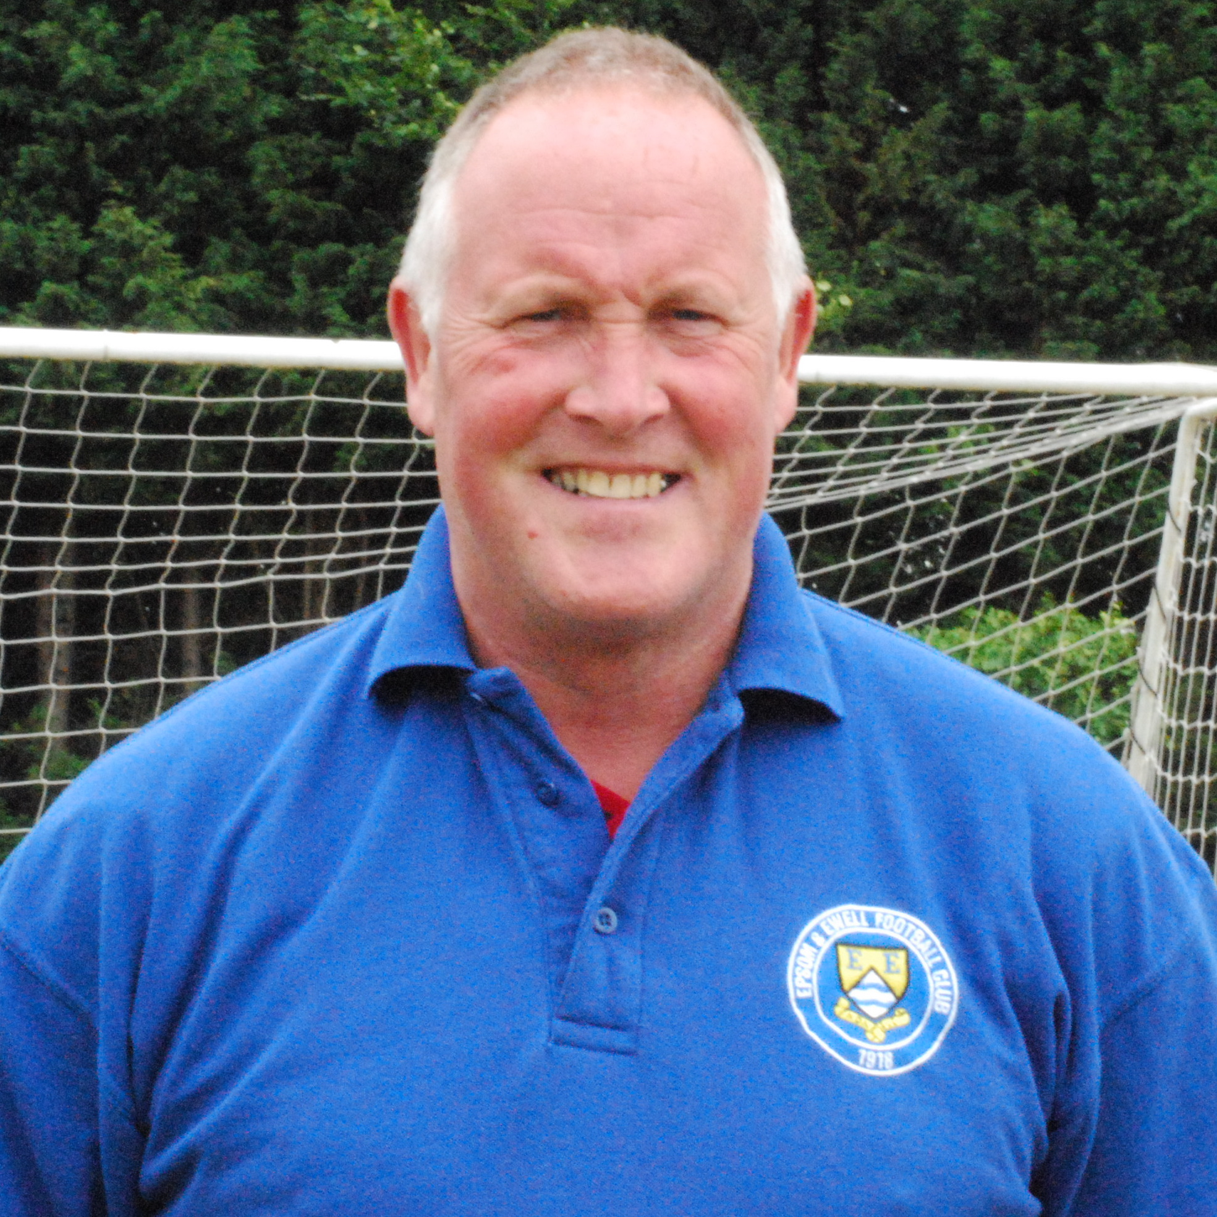
Favourite Football Team: West Ham United

Favourite Football Player: Bobby Moore

Favourite Ground: Upton Park

Favourite Food: Curry

Favourite Drink: Peroni (beer)

Favourite sportsperson: Pelé

Favourite Album: Best of Mike and the Mechanics

Favourite Holiday Destination: Cornwall

Clubs Played for: Epsom & Ewell, Cobham, Croydon Athletic

Best ground you’ve played at: Crawley Town

Personal aim for this season: Not to concede more than 30 goals in the League – Won’t be too far away!

Where will we finish in the League: Top two.

Did You Know?
That in all three of our matches so far this season the attendance has been 67. There is no truth in the rumour that it was the same people!!

Membership Form
Tony Foster is our new Membership Secretary. He would like to remind you all that your membership is due for 2010/11. Please either copy this form below or ask a Committee Member for another at today’s game. It is only £6 for adults and any cheques are to be made payable to Epsom & Ewell F.C.

If you want to post the form it goes to Tony as 396 Chessington Road, Epsom, Surrey, KT19 9EG.
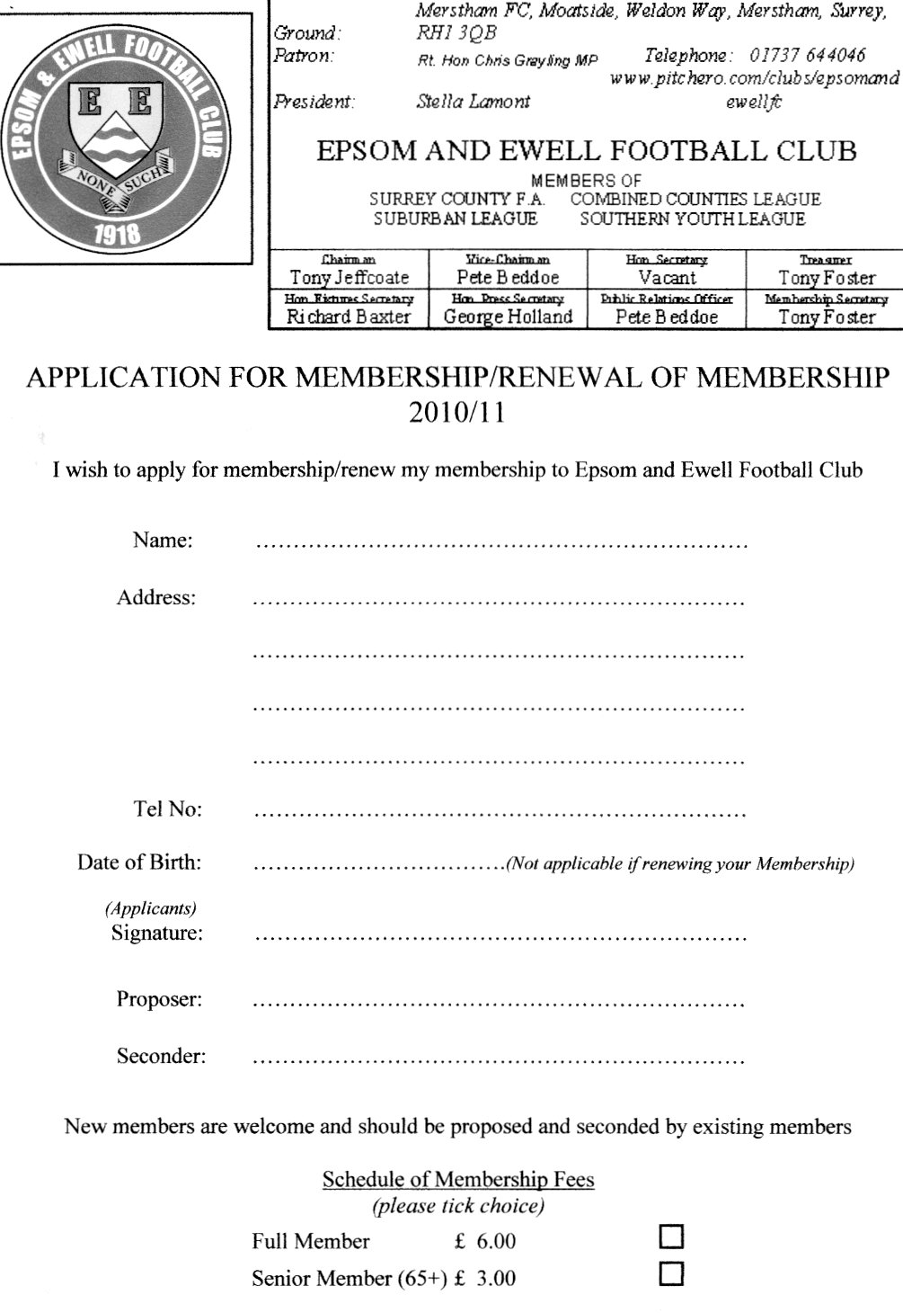

Apologies for the quality of the form, it didn’t scan very well!

Dorking F.C. Club History
The original Dorking F.C. was formed in 1880, making it the second oldest football club in Surrey after original FA Cup entrants Reigate Priory. In the early days the club was based in Pixham Lane, with the club achieving some success in 1910 when losing 0-3 to a strong Old Kingstonians side in the Surrey Senior Shield final. Dorking were founder members of the Surrey County Senior League in 1922 but aside from winning the league in 1928/29 and 1929/30 the club fell on lean times until 1948/49 when the club landed both the League Charity Cup and the inaugural League Cup.

1955/56 was one of the most successful in the club’s colourful history. Dorking won not only the league and the League Charity Cup but also in defeating Folkestone Town 3-1 became the first Surrey Senior side to defeat a professional team in the FA Cup.

The change of ground in summer 1953 to the current site at Meadowbank (which had been converted by the Council from an old rubbish tip) gave a boost to the club’s ambitions and in 1956 the club joined the Corinthian League. The team reached the final of the Surrey Senior Shield in three consecutive years (1959 to 1961) winning the first two finals (1-0 versus Kingstonian and 3-0 versus Sutton Utd) but losing the third 0-1 to Tooting and Mitcham. Following an amalgamation of leagues, Dorking joined the Athenian League in 1963/64 but the club did not prosper and 1974 saw the merger of the club with Guildford City of the Southern League to form Guildford & Dorking United. After just two sessions, however, the club collapsed in mid-season, with another club being formed called Dorking Town in 1977 to complete its predecessors remaining games before joining the Surrey Senior League in 1977/78 and then the Athenian.

In 1981/82 Dorking were elected to the Isthmian League where the club has remained ever since. Starting in Division Two South the team started steadily (finishing their debut season in 9th place) and the club were soon to adopt the name by which they are now known, Dorking. 1983/84 was notable for Andy Bushnell’s goal haul of 37 (the club’s record scorer in a season being Neil Goodman with 54). In 1986/87 and the following year Dorking finished just outside the promotion places in 3rd spot, losing out by one goal to Met Police and by a solitary point to Chalfont St. Peter with the club gaining some consolation when winning the Gilbert Rice Cup against Hastings Town.

Justice was finally done in 1988/89 when Dorking romped home as Division Two South champions by a massive 16 points, amassing 100 points and over 100 goals in the process of winning 32 games, with only 4 games being lost. The season also saw a notable Surrey Senior Cup win over Sutton United just days after Sutton’s famous FA Cup win over holders Coventry City. The club also reached the last eight in the league cup.
1989/90 saw the momentum continued with Dorking challenging for promotion to the Premier Division at the first attempt, eventually finishing in sixth place. The club also reached the final of the Surrey Senior Cup for the first time since 1886, beating Sutton United en route for the second successive season, but unfortunately they went down to Carshalton Athletic 2-4 after extra-time, despite leading 2-1 with only three minutes of normal time remaining. Twelve months later Dorking fell away in the league after spending much of the campaign among the front-runners. The club eventually finished tenth. The highlight of the season was reaching the 4th and final qualifying round of the F.A. Cup losing 2-3 at home to Cheltenham Town.

Season 1991/92 saw Dorking slip down a place in the league, to eleventh, but the club progressed further than ever before in the F.A. Trophy, making the 2nd Round Proper before losing 0-2 away to Bath City. The season culminated in a second victory in the Gilbert Rice Cup, beating Havant Town over two legs. Phil Grainger totalled 37 goals

that term. 1992/93 was probably the finest season yet in the club’s history. The greatest prize was finishing third and securing promotion to the Premier Division, which was a tremendous achievement in itself. Dorking also reached the 1st Round Proper of the F.A. Cup for the first time, losing 2-3 at home to Plymouth Argyle, led by Peter Shilton in front of 3,200 spectators. In addition, the “Chicks” reached two cup finals: they lost 0-1 to Tooting & Mitcham United in the Full Members Cup at Kingstonian, but won the Southern Counties Combination Cup by defeating Epsom & Ewell 1-0 at Meadowbank. Steve Lunn became the second player in successive seasons to equal the modern scoring record of 37 goals, and also created an all-time appearance record over the 350 mark.

Dorking’s appearance in the Isthmian League’s top flight was however short-lived and relegation followed in the club’s first season in the Premier Division. With a financial crisis enveloping the club in season 1994/95, new chairman Jack Collins stepped into the breach to try to save the club from liquidation, assisted by his son and vice-chairman Ray Collins. With the help of a small but dedicated band of helpers, Jack and Ray successfully managed to keep the club afloat and turn the club around, albeit the task proving to be a long and tough one. With attention being focused on the very survival of the club, it was inevitable that performances off the pitch were to suffer. With no player budgets in the mid 1990’s, the club saw relegation from Division 1 and then after several years from division 2 of the Isthmian League. With the onset of the new Millennium, and with stability reached off the pitch, Dorking enjoyed their best season for some years in season 2001/02. The club finished 8th in Ryman Division 3 and reached the fourth round of the FA Vase (Dorking’s best ever run in this competition), losing on penalties after a replay to one of the competition favourites Burgess Hill Town after two games that attracted over 1,200 fans over the two encounters. Season 2002-2003 proved a disappointment after hopes had been raised the following term. Despite some stunning results (including a 9-1 and 5-0 double over Wokingham Town and a 6-3 away win at Edgware Town) the side never recovered from a slow start and ended the season in 14th place in the new 16 team Ryman Division 2 with Steve Lunn assuming sole managerial responsibility during the course of the season.

Dorking enjoyed their best season for a while in the 2003/04 season. Management team Steve Lunn (manager) and his brother Andy Lunn (assistant manager), put together an exciting young local side and their efforts were rewarded with Dorking finishing as runners up in Ryman Division Two, 2 points behind champions Leighton Town who only overtook Dorking on the last day of the season. Finishing in the top two positions guaranteed Chicks a place in the newly constituted Isthmian Division One with the likes of AFC Wimbledon, Dulwich Hamlet as well as local rivals Leatherhead and Horsham. Promotion was secured thanks to a fantastic off the pitch effort, led by chairman Jack Collins, vice chairman Ray Collins and club man of the year Brian Cook, to obtain a grade B ground grading ensure the efforts of the team on the pitch were matched by the efforts off the pitch. Dorking had a decent baptism to Ryman Division One football following promotion, holding a comfortable mid table position well into November 2004. However a winless run of 13 games from November to February saw Chicks become embroiled in the relegation tussle and although Chicks only fell into the relegation spots in the last two weeks of the season, they lost a must win game at Whyteleafe on the last day of the season 3-1, leaving them facing relegation back to Ryman division 2. Highlight of the season was perhaps the Boxing Day clash at Meadowbank against AFC Wimbledon, which saw over 2,500 people watch the match.

Season 2005/06 saw the club reach the Fourth Round Proper of the FA Vase again but the team under performed on the day in front of over 500 fans against Mildenhall, who had knocked the holders out in the previous round. Off the pitch Dorking were rocked by the sad loss of many club stalwarts, including Jenny Collins, wife of long time club chairman Jack, as well as Brian Cook and Bob Long, plus Geoff Tyler who had passed away at the end of the previous season, individuals who had been the bed rock of the club for so many years, and who are simply irreplaceable at this level of football.

Dorking joined a revamped Combined Counties League in 2006/07 for the first time in their history following the disbanding, under FA instructions, of Ryman Division 2 in May 2006. Dorking under performed in their first season at CCL level, finishing in lower mid table and exiting the cup competitions at early stages. The season was overshadowed though by the valiant fight against cancer of club captain Stewart Vaughan, who was diagnosed in December 2006 with the condition, Stewart passing away in April 2007 shortly after marrying his long time girlfriend Heidi. A concerted effort by the club, fans, players and staff alike, saw Dorking host two charity games in honour of Stewart and in support of Marie Curie cancer care. The first saw Harry Redknapp pay his respects by bringing virtually his full first team premiership squad, including the likes of Lua-Lua, Glen Johnson and Matthew Taylor, in February 2007 in a game watched by over 2,000 fans, while a Crystal Palace X1 visited Meadowbank in April 2007 watched by over 1,000 fans. Soon after the end of the 2006-07 season, Steve and Andy Lunn parted company with the club and were replaced by ex Tooting & Mitcham, Epsom & Ewell and Leatherhead goalkeeper Tony Webb as Manager, joined by Peter Augustine as his assistant.

Season 2007/08 was a difficult one for the club, overshadowed by the club’s landlord, Mole Valley DC, taking steps to remove the club from its Meadowbank ground. The club stood its ground, convinced it was in the right, a position that was vindicated by the judge after a 3-day court hearing in April 2008, the club being awarded a new long-term lease by the court and also the bulk of its considerable legal costs in having to fight MVDC. While the court victory was central to the very survival of Dorking FC, inevitably the short-term fortunes of the first team on the pitch suffered and the club suffered relegation at the end of the season despite the valiant efforts of Tony Webb.

With the court action out of the way, Webb was able to concentrate on football matters and Dorking FC bounced back to the CCL Premier Division at the first attempt, promotion being achieved in dramatic style in a very tight finish to the season, Chicks going up courtesy of one goal goal difference over the 4th spot side, and missing out on winning the league by just two points. Dorking started solidly the following season back in the CCL Premier, but the resignation of Webb in November for personal reasons saw a period of disappointing results for the club. Peter Augustine stepped into the breach as first team manager in January 2010, but he was unable to turn the ship around and Dorking finished in bottom spot come the end of the season.

With Augustine stepping down as first team manager at the end of the season, the club appointed Adrian Cox as manager, assisted by Peter Buckland and John Badillo as coach, the club receiving a reprieve from relegation following developments in the football pyramid. The new management team are aiming to attract local players to the club, while the club’s Under 18 side continues to build on the foundations laid in recent years by Gordon Walker, Simon Coffey taking over the managerial role this season with Nick Torpey and Gordon assisting.

Our new Website
Do you like the new website?

Janice Pond has kindly stepped in to facilitate a move to the pitchero group of websites, and as you can see below, it looks very professional.

While our previous website was also good, this has a couple of advantages. Firstly it is a new look, which makes a nice change, and secondly, many people can update it, as access is being granted to all Committee and Playing Management.

To join up, all you have to do is enter the website and then join pitchero as a member (the link is up in the top left corner) and select the club name. From there you’ll be asked which categories of membership you require. Supporter or player would be your first box to tick, but there are other categories too.
Just go to http://www.pitchero.com/clubs/epsomandewellfc/ and you’ll see all of this.
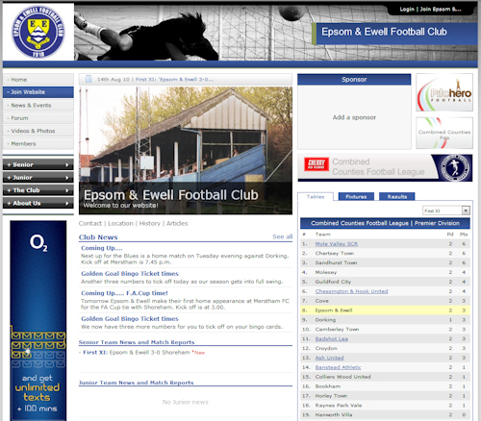

This page for appearances spreadsheet (centre pages)

This page for appearances spreadsheet (centre pages)

Golden Goal Bingo Ticket update
Following Saturday’s win over Shoreham, you now have seven numbers to mark off on your cards. They are as follows:

Date | Comp | Opponents | H/A | F/T | Goal Times
07/08/10 | CCL | Sandhurst Town | A | 1-3 | 57
11/08/10 | CCL | Croydon | A | 3-0 | 13, 50, 55
14/08/10 | FAC | Shoreham | H | 3-0 | 10, 38, 45
Here is everything you ever wanted to know about the Epsom & Ewell F.C. Golden Goal Bingo tickets:

This fund-raiser will run throughout the season in four separate scoring periods, the first of which is August and September. The cards cost £5 each and have twelve numbers on them.

For every competitive goal that the Blues score we will advise the minute of the goal on the web site and in the match programme.

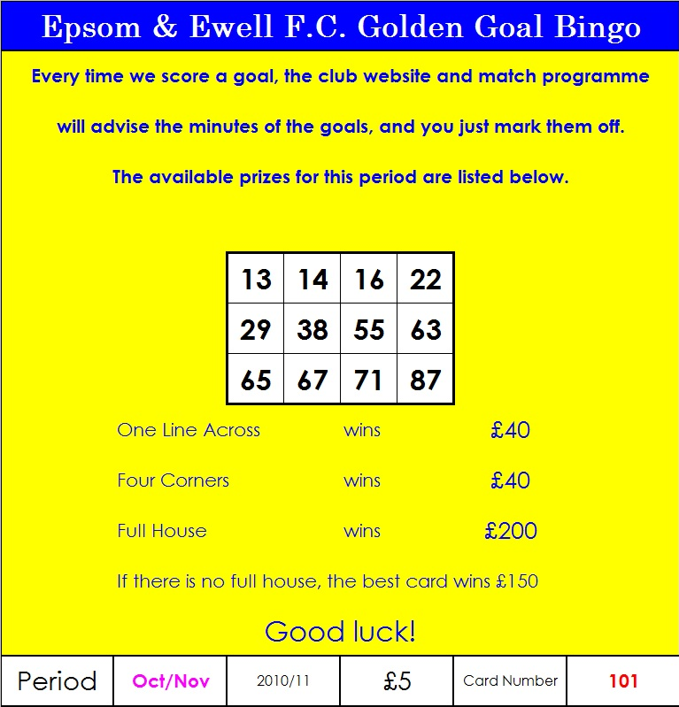
You simply mark the numbers off and claim your prize by producing the card. You can win by getting four numbers in an across line, or by marking off the four corners. Either way you can win £40, but the real prize is for the Full House, which is £200. Just in case a full house isn’t won, we will be aware of the nearest card and will advise its number accordingly. The winner of this “best card” will get £150.

These are big prizes, but they could get bigger still. It is down to everyone out there to sell as many tickets that they can. Even if just ten of you took ten to sell at work, then that would raise £500 towards the Fund-Raising Exercise.

There are terms and conditions, but they are fairly standard things, like having to be over 16 to play, and every ticket explains the claiming procedure. Just remember to hold on to them, as we will announce all winning numbers for the first scoring period in the first few days of October. Ticket number 101 is shown below, and as you can see it has already marked three numbers off, and we’ve only just started. There could be another twelve matches in this scoring period!

The Epsom & Ewell F.C. Fund-Raising Thermometer!
We currently sit at £645 at present, having sold a few more Bingo tickets on Saturday. Ticket 101 above is still for sale by the way, and will be in one of the envelopes tonight. Also, on sale from next Saturday is the 50 Epsom Legends Book, which is on sale for £10 and is limited to 50 copies.

We will be announcing further fund-raising efforts in the near future so watch this space!

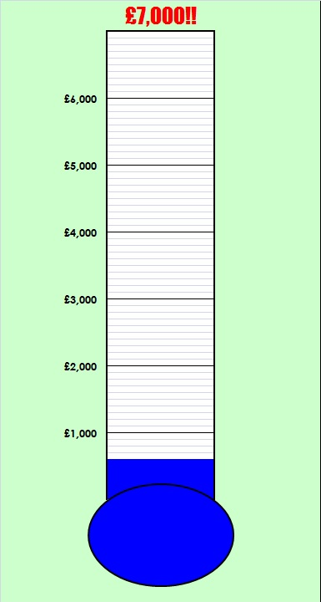

100 Memorable Matches
What makes a memorable match?

A match can leave us with memories for a number of reasons. It could have been a big game like a cup final or promotion decider; it could have been a wild match with lots of goals, a big win, or even a heavy defeat. Add freak weather conditions, an odd refereeing decision, or just something a little bit special and you have a list of about 500 matches.

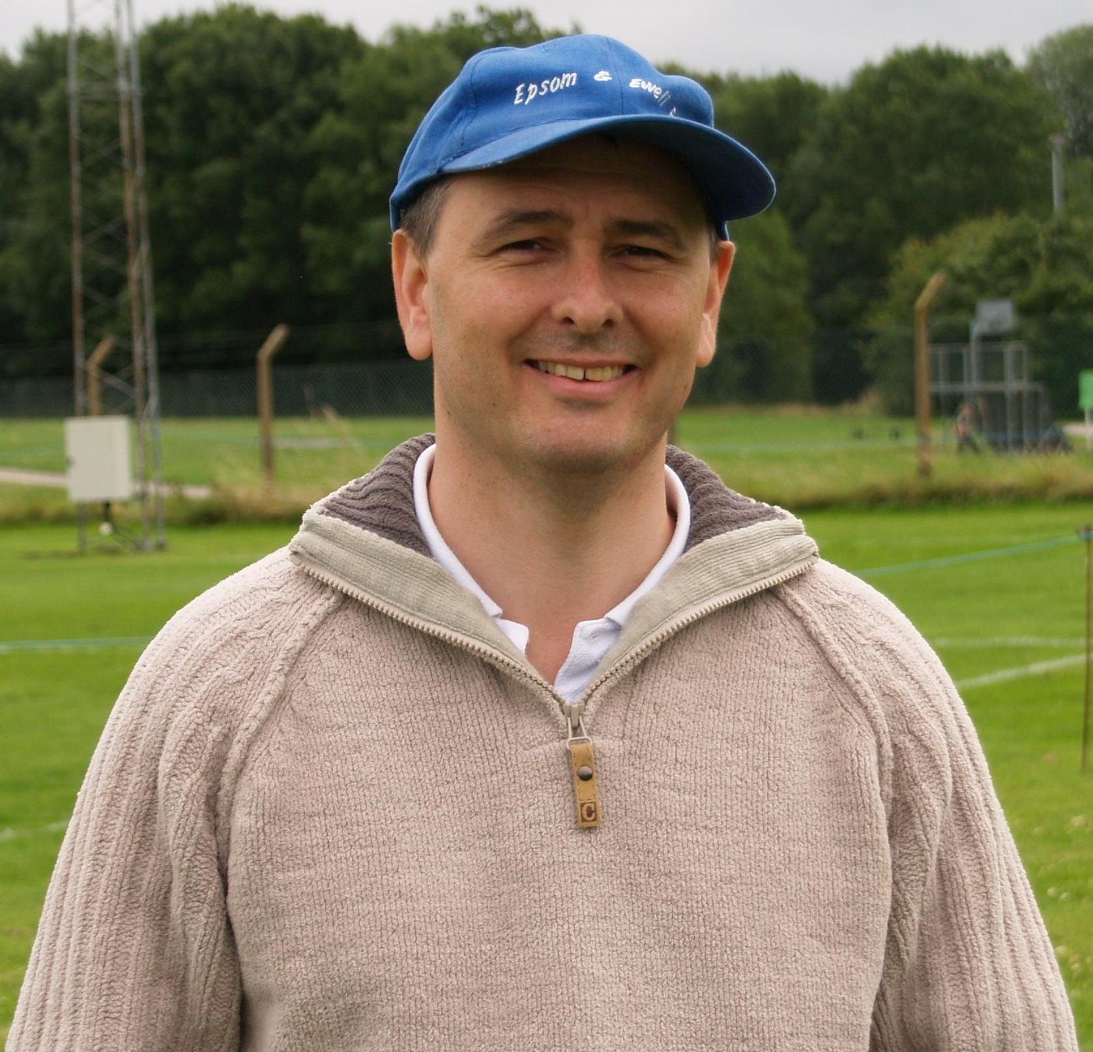
To try and get this list down to 100 has been an extremely difficult task. Occasionally I have put matches together for obvious reasons, as you’ll find out over the course of the season, and by the end of the season, we’ll find out which was top of the list.

95 – Epsom Town 1-3 Dorking & Epsom Town 2-2 Addlestone
Friendly & Surrey Senior League
Saturday 30th August 1924 & Saturday 6th September 1924

On the face of it, these two matches don’t look particularly exciting, but at the time they were the biggest football events to happen in the town’s history.

The club had been founded six years earlier, but had progressed further than any previous incarnation of the Epsom club had. In 1923/24 the club had breezed through the Intermediate ranks and was elected unanimously to the Surrey Senior League. Effectively, all the real club records start here.

So, on the last Saturday in August 1924 Dorking visited us at Horton Hospital Grounds for our first ever match as a Senior club. Over a thousand were present to witness the Blues first steps at the new level. Even though this was only a friendly, the term “challenge match” was more often used back then, and indeed friendlies remain part of club records until 1960 when our club started playing more pre-season matches.

Some regular players were missing this day and the club took the opportunity to try out some new ones before the League campaign kicked off seven days later with a visit from Addlestone. The friendly was lost 3-1 although Sid Bristow (Epsom Legend Number 3) scored our first ever goal at this level with a penalty.

Against Addlestone our boys dominated yet trailed 2-0, although they recovered to draw 2-2, with Nickless and Jack Parr scoring the goals for Epsom Town, again in front of around a thousand spectators.

94 – Epsom & Ewell 3-5 Aveley – Isthmian League Division Three
Saturday 21st December 1996

If a dictionary actually contained definitions of phrases, then if you looked for the listing of “freak weather conditions”, you’d find a report of this match! We all recall bad weather at Merland Rise, and I often referred to the area having its own micro-climate, but this one was generally accepted as the worst day of weather we encountered in our time there. It was windier at Moneyfields last season, but that was all in one direction, whereas at Banstead, the wind and rain used to swirl around.

We went downhill with the strong wind mostly at our backs, yet trailed early on when a shot was aimed for the top left corner but went into the right hand side-netting!

However the Blues got into their stride and turned the game around to lead 3-1 through Paul Meredith, Andy Boxall and Martin Jones. Meredith also hit the post shortly afterwards.

Despite leading by two goals, the Aveley keeper, who was clearly of Caribbean descent as he was totally laid back and wasted much time, despite howls from us to the referee about speeding him up. Not that we could be heard anyway!

The keeper clearly felt confident that his team could turn it around in the second half and so it proved as Aveley netted on four more occasions to win a wild game by five goals to three. Bizarre!

93 – Epsom & Ewell 0-0 Cheshunt – Isthmian League Division Three
Saturday 23rd January 1999

And on the subject of bizarre, step forward Mr Ralph Bone, match referee this day. This is one of only two goalless draws and understandably so in our list of memorable matches. But this match was memorable for so much more than the lack of goals.

Our earlier match that season had been a 1-1 draw with the Blues having a penalty saved by a very good keeper. He was in goal for the return at Merland Rise, and he faced another penalty in the second half of this match. It was deserved as the Blues had been the better side, but the keeper made a great save from Micky Owen’s kick.

Within a couple of minutes though, we had earned another one. This time Paul Bunter stepped up and scored from the spot, until the referee decided that there had been encroachment from one of our strikers. Oh well, we thought, at least we still have another go at the penalty but it was not to be, as the referee then awarded Cheshunt a free kick for the encroachment and his Linesmen said nothing to change his mind despite players, Management and supporters going ballistic around the ground. After the game the referee realised his mistake and came into the dressing rooms to apologise to our players, but the damage was done.

Here’s the strangest bit. This referee was on the Football League list not long afterwards, while Cheshunt were promoted ahead of Lewes, by… you’ve guessed it, one point!

92 – Ruislip Manor 3-4 Epsom & Ewell – London Senior Cup
Saturday 13th November 1982

I had not been watching the Blues for very long, and had started watching all the away games that season. We travelled to little Athenian League side Ruislip Manor’s Grosvenor Vale ground expecting naively that this would be a stroll in the park. However, we were not a great team ourselves that season as Adrian Hill was just shaping the team in his first full term in charge, and this would prove to be very tough.

We raced into a three-goal lead at the Vale. Kelvin Roots, Steve Milton and a great Dave Barnard free kick had us all in great spirits as we retired for a half time hot dog. But the second half was scary as first one goal was pulled back, then a second and finally an equaliser. Cue panic amongst the supporters, but one man kept his head, our star striker Steve Hill, and he popped up to score the winner in the last couple of minutes to avoid the need for a replay. Phew!


A little Oasis!
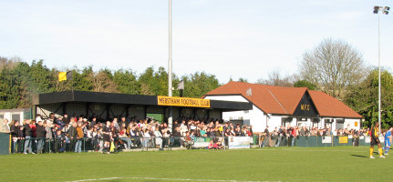

Ok, so there weren’t quite that many in the stand on Saturday, although it filled up quite rapidly when that downpour started!

I think I speak for all of us at Epsom & Ewell when I say a big “thank you” to Merstham Football club for their offer of a groundshare. The only issue that some people may have had was the distance from our home Borough and we obviously hope to return as soon as possible as we await news on our negotiations with the Council. But for now, I can’t think of a nicer place to be.

Moatside is a very smart and tidy place, while the people I have met already are very down to earth and have no delusions of grandeur like some local teams we could mention. Obviously comparisons with our former groundshare are pointless, but in addition I already feel that we are more welcome here than we were at the Rise.

I am also aware that we may pick up a few “second-hand supporters” as they choose not to travel to Merstham’s away games. We apologise to Graeme Banyard if we have pinched a few of his travelling supporters, but trust that you will enjoy your time watching us as much as you enjoy supporting your own team. We know “Banners” well from his time in charge of Banstead Athletic and are sure he will understand!

As with last year we will be covering the Ryman League Division One South throughout the season but we will also take a closer look at our new landlords results, and who knows, maybe next season we could be playing them on level terms. Here’s hoping!

In the meantime, I hope our own supporters enjoy their time here. As you will not require the programme to tell you, this ground is like a little oasis of green in what, like Epsom is these days a fairly built up area, and once our ground is finally up and running, we would do well to follow the same excellent model that Merstham have in place here.

Matches against Merstham
I first visited Merstham’s ground for an Epsom & Ewell friendly back in August 1990 as Adrian Hill’s developing side were defeated by two goals to nil by a side that were a division below us at the time. It’s fair to say that the ground has changed a little too, with only the little stand in the corner being in existence at the time. My memory tells me that it was wooden, but it was a long time ago so I could be wrong!

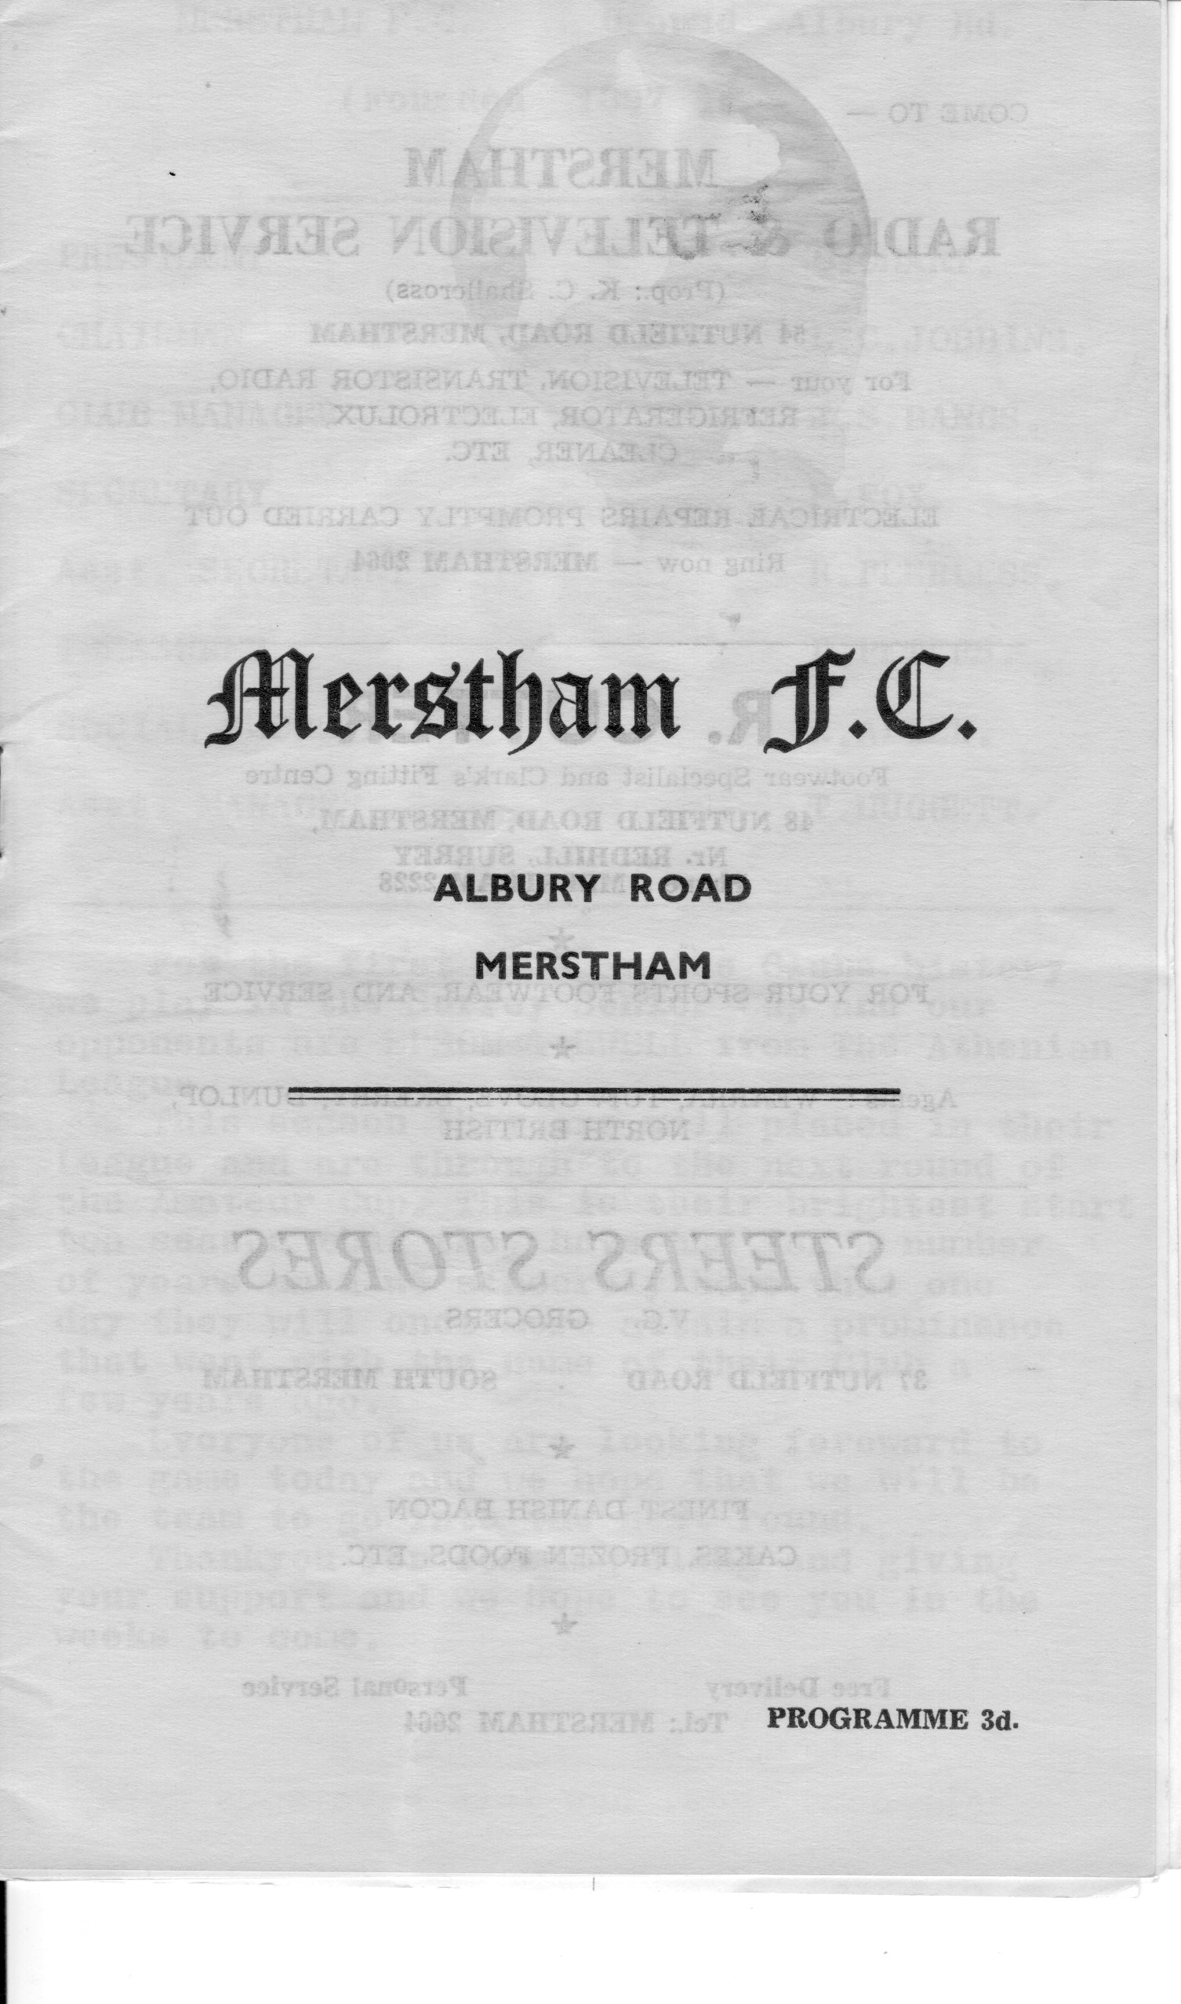
In terms of competitive matches, we have met on eleven occasions starting way back on 13th November 1965 for a Surrey Senior Cup tie. Back then our former striker Johnny Bangs was Player / Manager here and another former Epsom player Albert Pollington was expected to be in the team, but the Surrey Senior League team were no match for us that day as Epsom cruised to a 5-0 win.

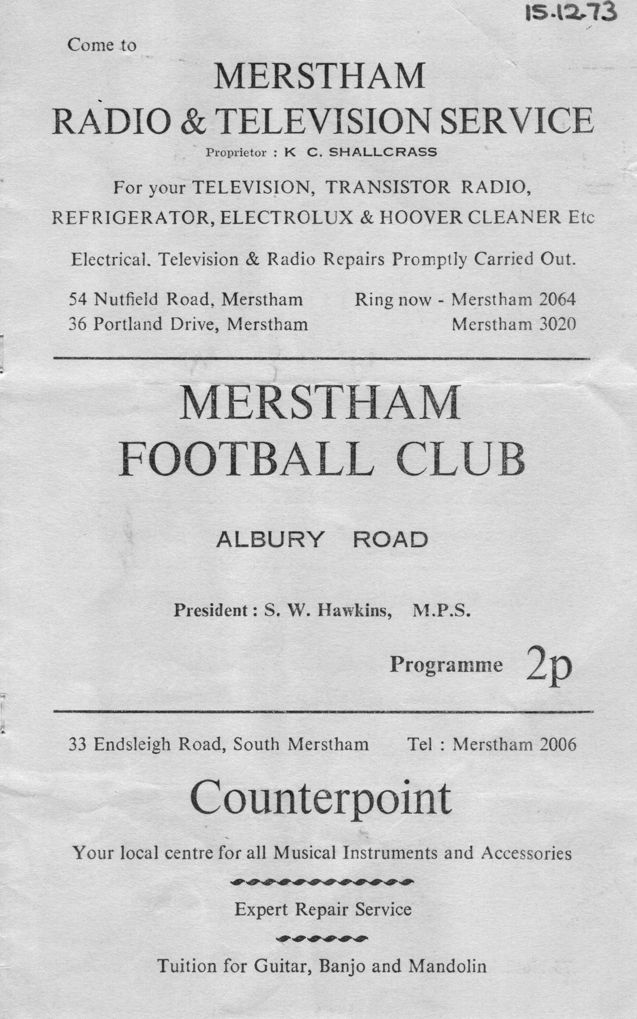
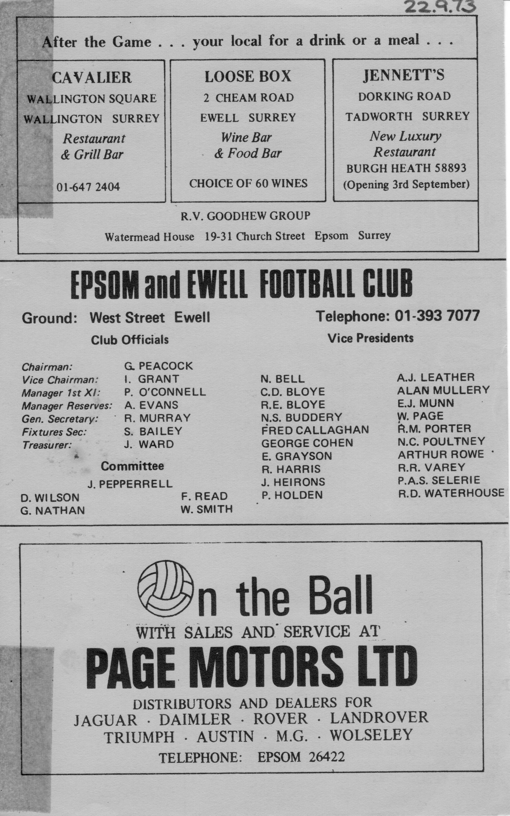
The next eight years were depressing for Epsom supporters, but in 1973 Pat O’Connell was the new Manager, and our first win of the “new era” was on 22nd September 1973 when a goal in each half from Tommy Tuite gave Epsom a 2-1 League win over Merstham at West Street. He scored two more added to a goal from Alan Webb as the Blues won here 3-1 at what was then known as Albury Road in December of 1973. Both programmes are shown here.

In 1975 we actually met four times. The first two were League matches, winning 6-2 at West Street with a hat trick from Tommy Tuite, together with two from Phil Walker and one from Trevor Lee before both went on to Millwall.

Exactly five weeks later, Walker scored again along with Dave Ritman and Pat O’Connell in a 3-0 win, whilst at the end of April a tired Epsom side managed a 3-1 win at Albury Road on a Monday night in the Surrey Senior League Charity Cup Semi-Final.

However since that match, our sixth meeting, we haven’t beaten Merstham again. Our next match in November 1975 was an F.A.Vase match. The Blues had just gone to Wembley in the first F.A.Vase Final and were keen to return, but in a bizarre match Merstham trailed 3-2 at the half, but recovered to defeat us 5-4 at West Street. (see programme right)

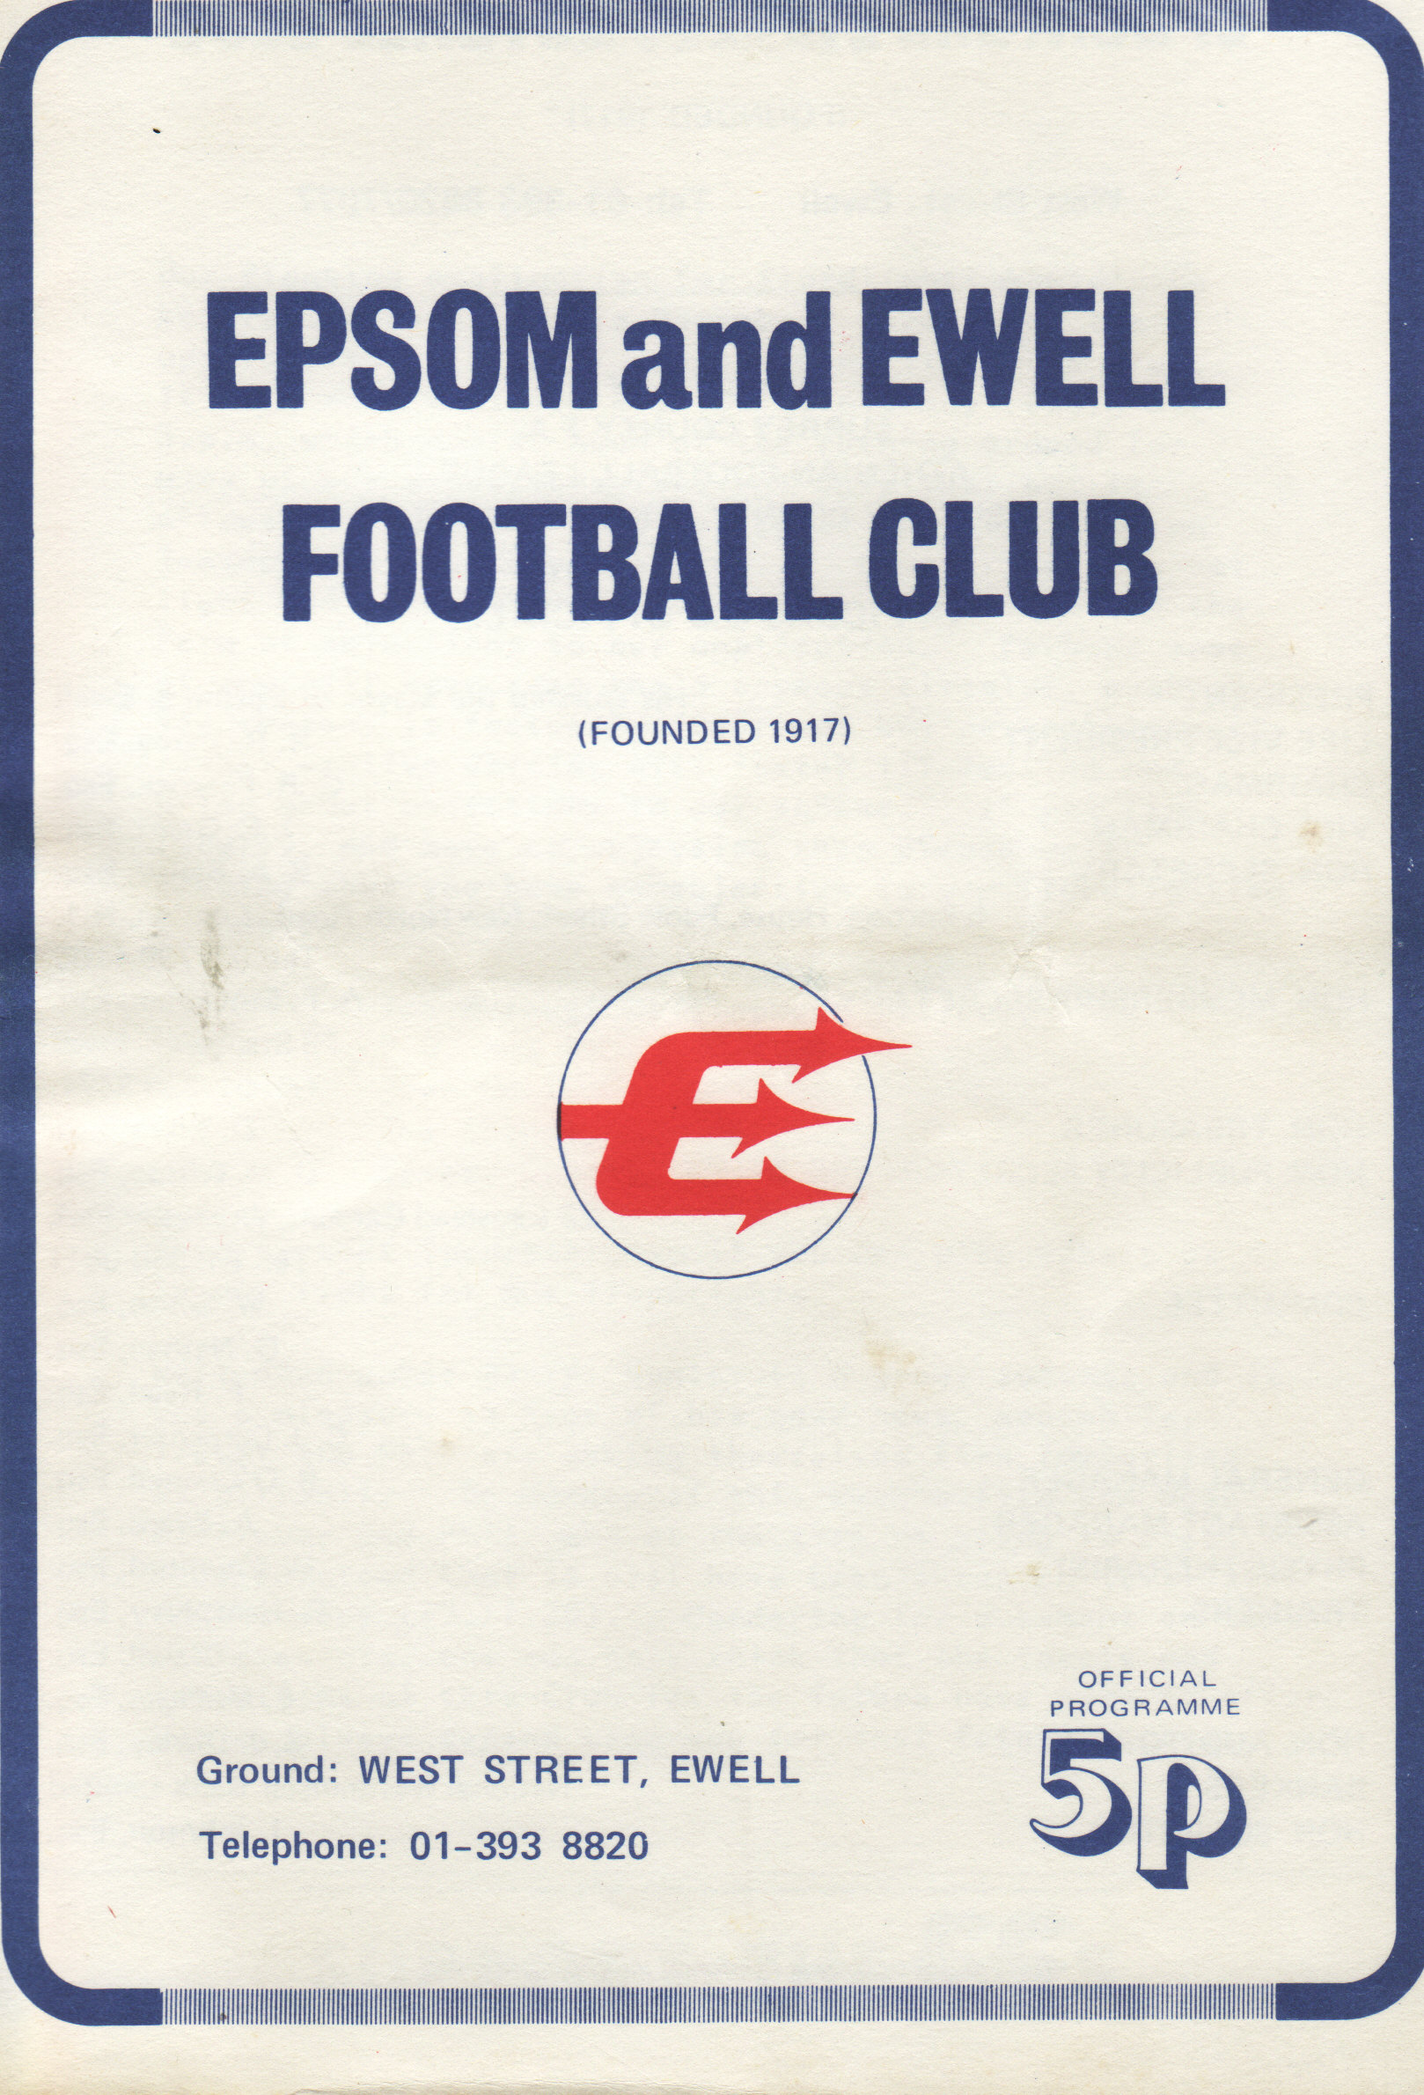
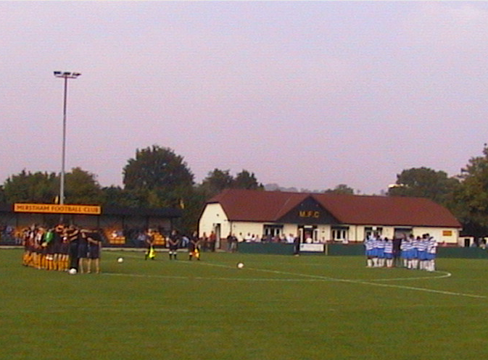
Step forward thirty-one years to 2006. After a gap during which we had only met in occasional friendlies, fate decreed that we would be at Moatside for the first match after the death of our popular Secretary Dave Wilson. A minute’s silence was held and the Blues took a surprise lead from Philip Ng’bale, but Merstham recovered and a late, late winner from Charlie West in his pre-Epsom days gave them the points. We were not a good side this season, but you could see signs of recovery under Lyndon Buckwell in the return match where we held Merstham for about an hour before conceding three times.

2007/08 was Merstham’s season. They had a tremendous year and brushed us aside 4-1 in January at Merland Rise, but a stunning strike from Kyle Hough earned us a deserved 1-1 draw against Mick Sullivan’s team.

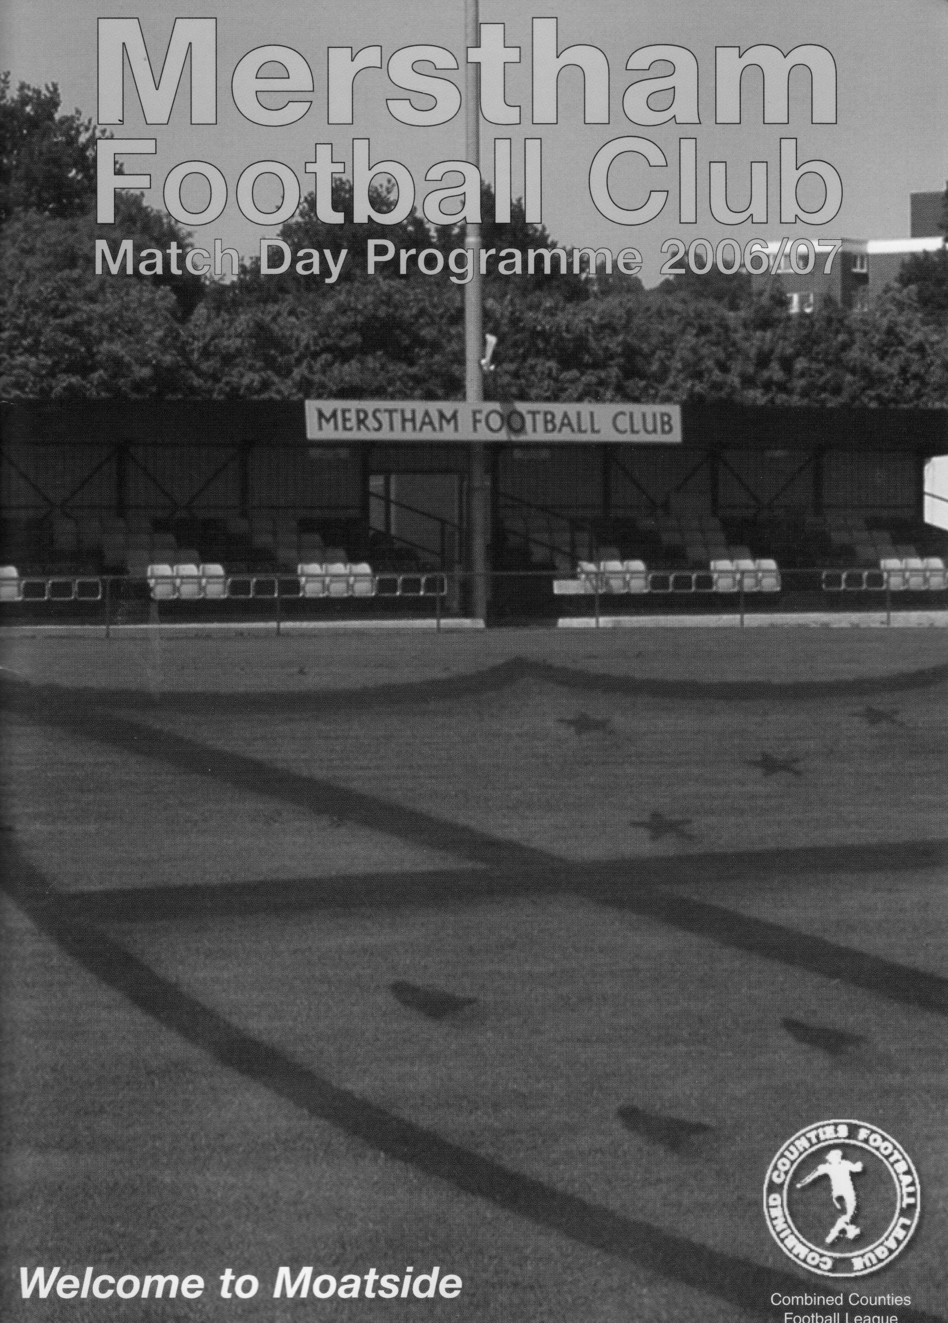

Steve Dyke
Roy Hodgson- My part in his past

(and vice versa)

As I got up this morning the media was full of comment about Roy Hodgson preparing for his first Premier League game in charge of Liverpool. Roy has enjoyed an interesting career, which if he revives Liverpool this season may be about to reach its pinnacle (although getting Fulham to a European Final is a huge achievement in itself).

He has an impressive CV with success in many places across Europe (except Blackburn) but there is one brief backwater in this CV, where he was not able to be a success that few people are aware of.
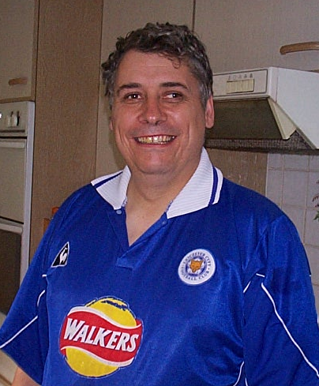
But I am!

I have written in these columns about my experiences as a young Bristol City supporter and explained it with the phrase “It’s a long story”. Well it’s now time for that story to be told.

My family connection with the Bristol area was through my dad’s cousin Auntie Freda who we used to go and stay with and have really good holidays. It’s a nice area with lots to see.

One day in 1975 we arrived there and Uncle Ken (a City season ticket holder) despite living in Rovers territory in North Bristol said, “who wants to go to football tonight?” I was 10 and football mad; it was the school holidays. Yes I wanted to go to football tonight.

Then my mum piped up. “You can all go, but Stephen’s too tired after the journey so he can stay here. Heck we’d been on a National Express coach for two hours – gruelling, but hardly hopping to the North Pole with Ranulph Fiennes.

At that time City were going up to the First Division for the first time in about 60 years and my dad and Geoff came back mighty impressed with a young centre forward called Paul Cheesley. Right I thought, they’re my team … Bristol City.

City did indeed go up. The first match was Arsenal away at Highbury. Arsenal had just signed Malcolm Macdonald “Supermac!” for an astonishing £ 333,333. All the countries media were there expecting a slaughter. Bristol City won 1-0 with a goal from Cheesley – what a team.

The very next game was Stoke at home, but Cheesley was badly injured and never played again. I never saw him play live but many people have told me he could have gone on to be England’s centre forward for many years – a big man with pace and a good touch.

City’s four years in the top flight were characterised by a constant will he, won’t he come back for Cheesley, but he never did. In September 1979 City stood 3rd in the top tier of English football. Three years later they were bottom of the 4th division after a plummet of three consecutive relegations, which will never be equalled.

City’s promotion winning manager Alan Dicks had put all his then young players on long contracts on first division wages to prevent poaching by other clubs. The first relegation was a disaster economically as the team had all grown old and stale together. Dicks was sacked and Malmo’s European Cup final manager Bobby Hougton was hired to sort out the mess. With him was his young assistant Roy Hodgson. A further relegation followed and in January 1982 the club went bust and nearly died.

As a result of this Houghton left, and the old guard of players on big contracts left too (Geoff Merrick, Jimmy Mann, Clive Whitehead). Hodgson took over and had to see out the rest of the season playing a Youth team in a men’s league. It’s apt I write this today as that’s what Dorking did for much of last season. As our visitors will tell you, that’s hard to do and Hodgson couldn’t prevent relegation from the 3rd to the 4th.

Maybe some of his potential was revealed in the fact that in that four-month spell City rarely got badly stuffed but just couldn’t score. Some of those players went on to have good careers – Rob Newman having started at 16 had 350 games under his belt when he went to Norwich in his early twenties.

City’s board appointed my all time football hero Terry Cooper and the slide bottomed out in 1992/93 reviving to a mid table finish and promotion the following year. Hodgson went on his travels having kept the club alive in it’s most difficult time. There was one pundit who knocked the appointment of Hodgson to the Liverpool job saying, “ he did nothing at Blackburn - he did nothing at Bristol City” … Context is everything.

Every Opponent A-Z
Over the years we have played many, many different opponents. Exactly how many is a difficult question, as it all depends on your definition. Are Camberley and Yorktown different to Camberley Town, or are Epsom Town different to Epsom F.C. or Epsom & Ewell F.C.?

In my analysis I have classed them as the same team, and will work through them all from A to Z. Some we have played many times, whilst others maybe just once or twice. Enjoy!
-----------------------------------------------------------------------------------------------------------------

Addlestone (and Weybridge):
Played 21 - W12, D3, L6 - F58, A28
Points per Game - 1.86 - Good

Addlestone were a team that I have already referred to in today’s other series, 100 Memorable Matches, as our first ever Senior status League match was at Horton Hospital Grounds against this team. That game on 6th September 1924 finished 2-2, but the return match was played just three weeks later in front of 1,200 spectators at their ground back then of Green Lane, Addlestone, where a goal in each half ensured a comfortable Epsom victory.

We recorded two big wins the following season, and three more in 1926/27 including a 4-1 win in the Surrey Senior Cup at their next ground in Alexandra Road, but our promotion to the London League meant a break of nearly thirty years before we met again. In January 1954, we were members of the Corinthian League, while our visitors to West Street that day were members of the Parthenon League and were beaten 5-0 with a hat trick that day from Reg Oakes, uncle of our former Treasurer Robert. Bill Wiles got the other two in this Surrey Senior Cup tie, as the Blues went all the way to the Final.

Addlestone had their first success over us in an Amateur Cup tie in 1958, played at a more familiar venue, Liberty Lane, and almost three years later to the day they knocked us out of the same competition again, this time at West Street. We met four times in the Athenian League during the dark days of the early seventies, winning both in 1971/72 but losing both in 1972/73, but the biggest meetings were around the corner.

In 1974/75 we returned to Liberty Lane for a Surrey Senior Cup tie. We were a very good team that year, tearing up the Surrey Senior League, but found ourselves 4-0 down before recovering to 3-4. Six weeks later on 1st March 1975 they visited West Street for the Quarter-Final of the F.A.Vase. The visitors were the new favourites for the competition, but that didn’t bother Epsom & Ewell who had rarely been favourites throughout their run, and the Blues won 2-0 with goals from Tommy Tuite and Trevor Wales, eventually ending the season at Wembley Stadium.

We met three more times in the late seventies, winning one, drawing one and losing one, and our last battles were in 1983/84 with Addlestone and Weybridge, as they were by then known following a merger / absorption of a very famous team in the late years of the nineteenth century, Weybridge F.C. We drew 1-1 at home in this Surrey Senior Cup tie, but won the replay 2-1 in our last ever visit to Liberty Lane.

Adrian Hill was so impressed with their keeper Andy Abel, that he signed him a week later and he was in goal the day we won promotion to the Isthmian Premier Division.

Alas, there was no happy ending for the Stones as they lost their ground to housing just a couple of years later and folded, leaving just one remaining trace. Godalming Town’s grandstand at Weycourt was purchased from Liberty Lane, and after a year or two lying in pieces it was eventually re-erected, and we will get to see it later this year as Badshot Lea currently share the ground with them.

A.F.C.Newbury: - Played 1 – W1, D0, L0 – F6, A1 – Points per Game – 3.00 - Perfect

A.F.C.Newbury were a completely new team unconnected to the previous Newbury Town who we met quite a few times at Faraday Road in the eighties and early nineties even though they used the same venue. We only met once in an F.A.Cup tie at Merland Rise and played on a Sunday and were up by four goals at half time with two from Jamie Goodwin, and other goals scored by Richard Ingham, Luke Jones, Adam Stones and current Epsom player Chris Read when he played for us previously.

In 2006 they lost their ground, and resigned from the Wessex League. They now play in Youth football only. Football still continues at Faraday Road with another club now playing there by the name of Newbury and they are currently in the lower reaches of the Hellenic League. Wikipedia advises that they had a very famous young player by the name of Theo Walcott. No he didn’t play against us back then, although well-known former Southampton player Nicky Banger was listed as being on the bench according to the programme.

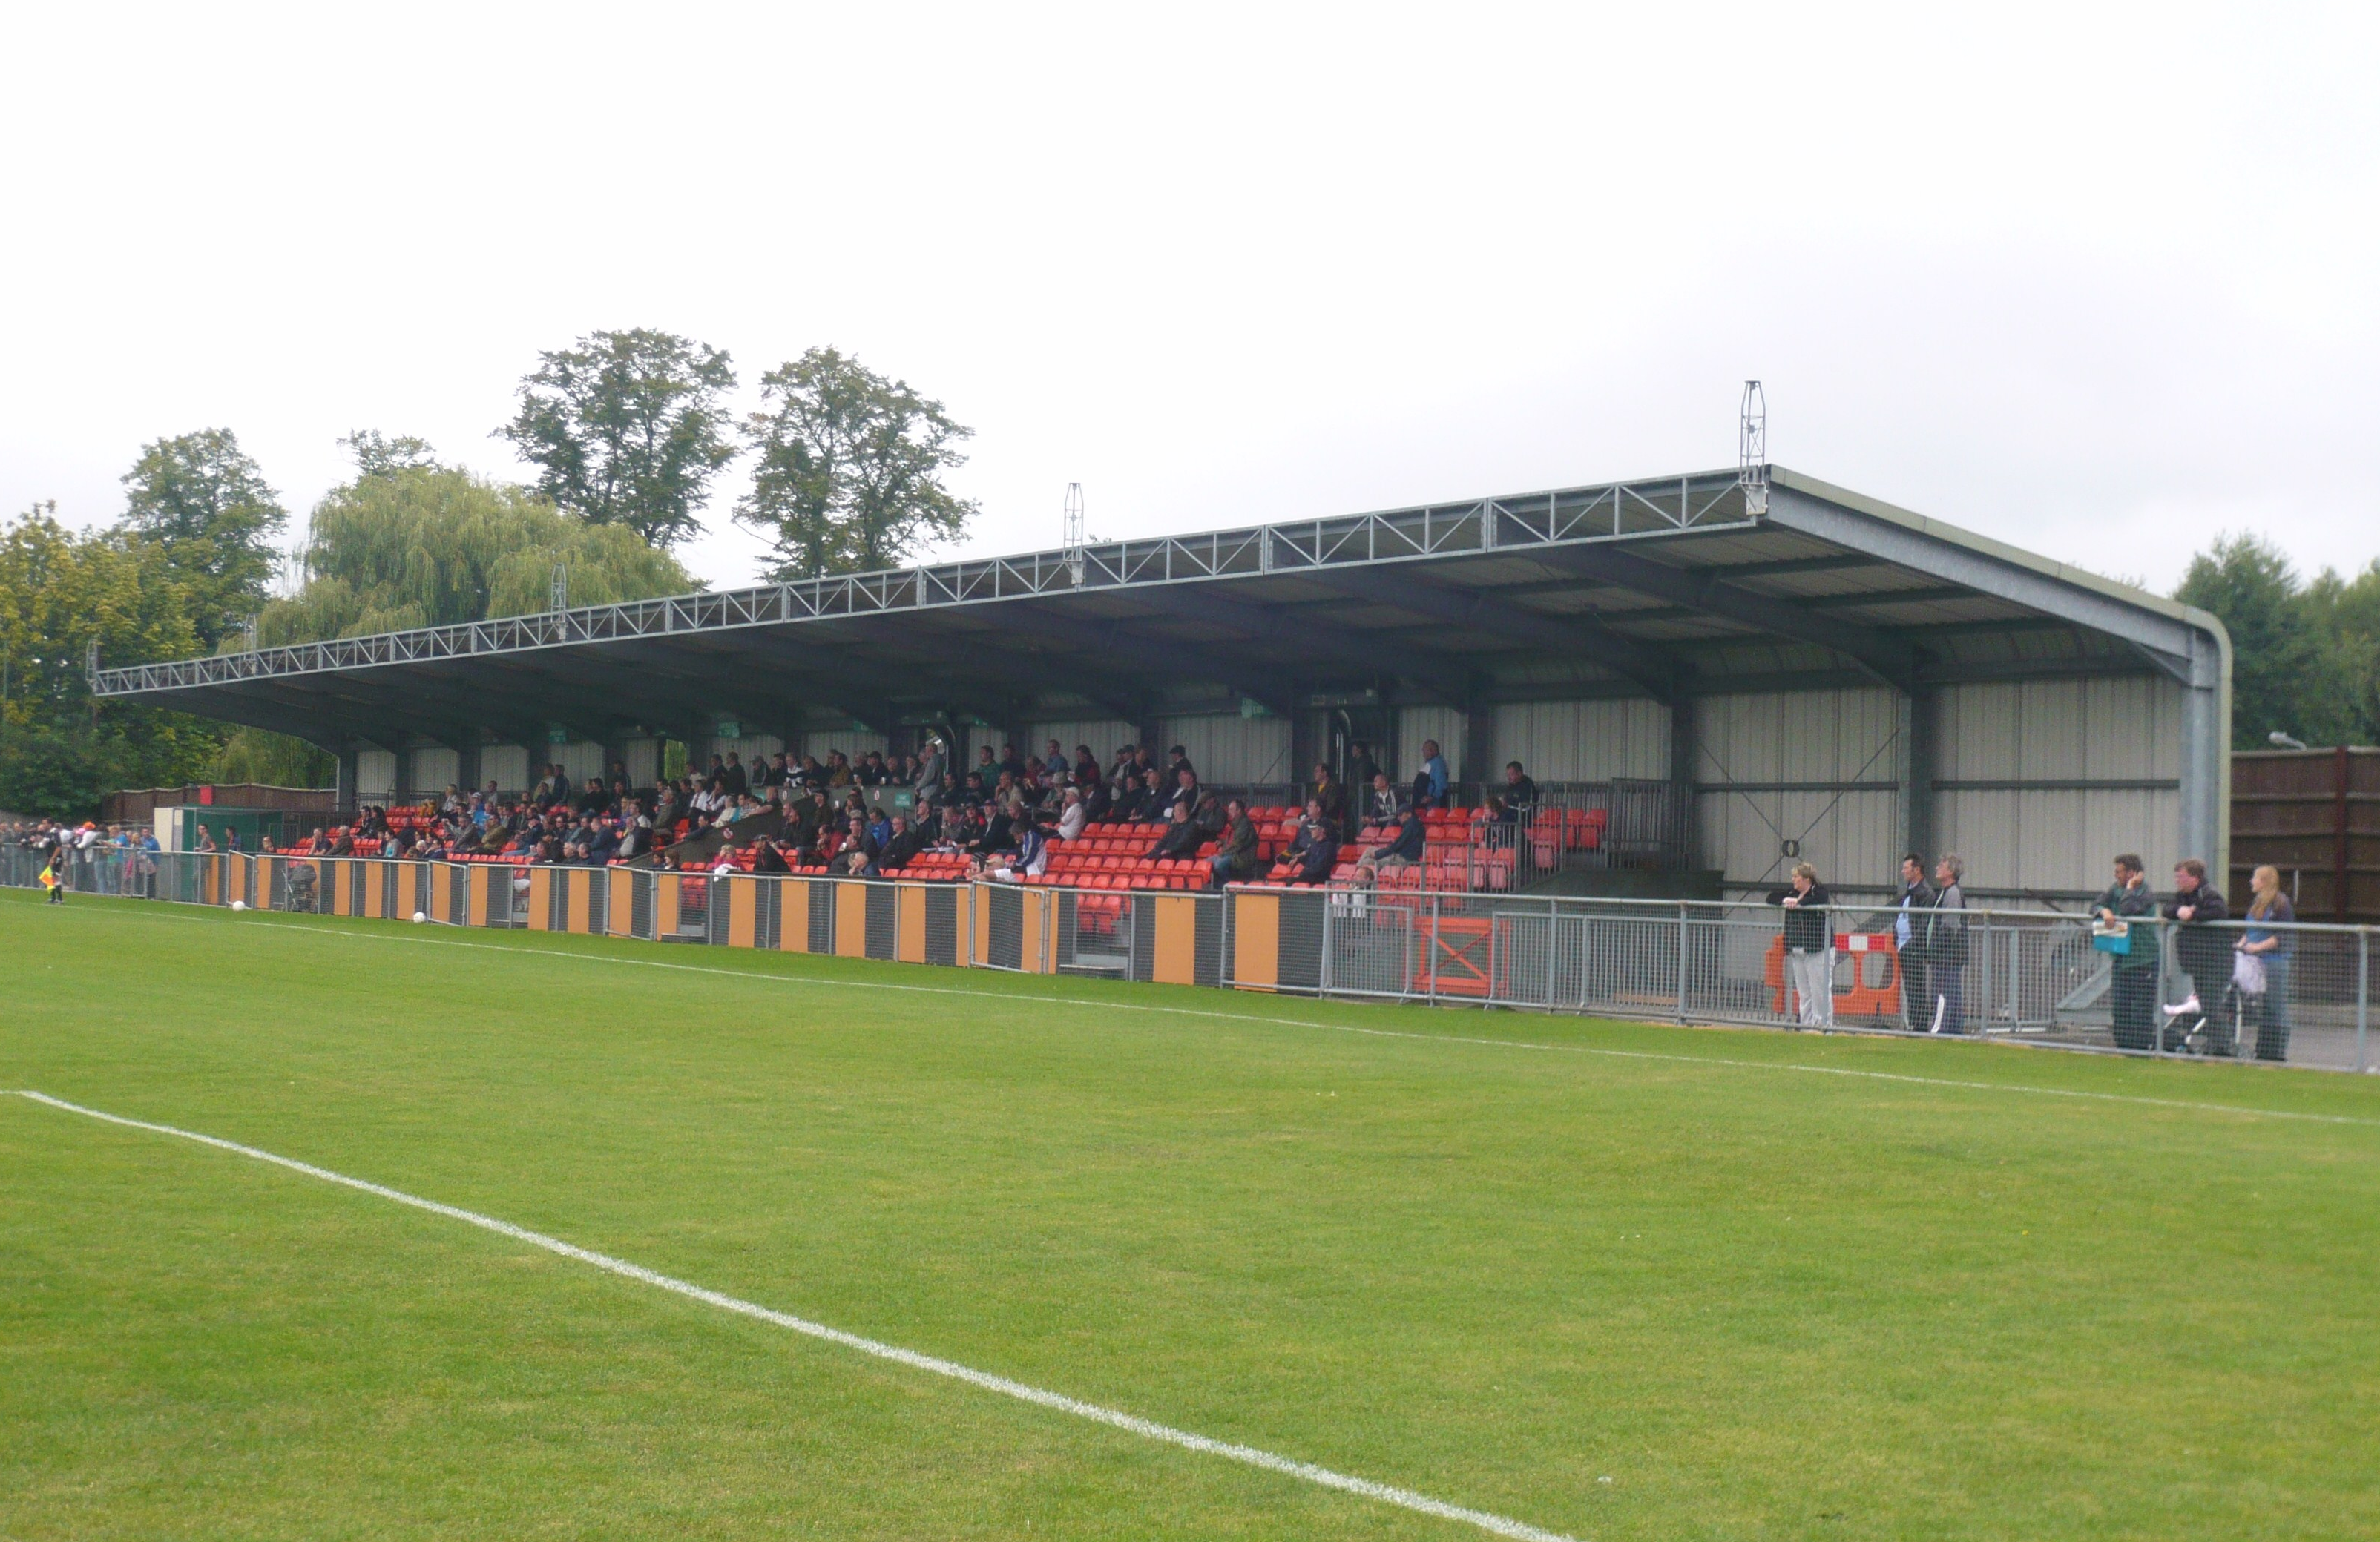

This is how Newbury F.C. looks now. The old stand from the eighties has been replaced.

Combined Counties League Cup Draw
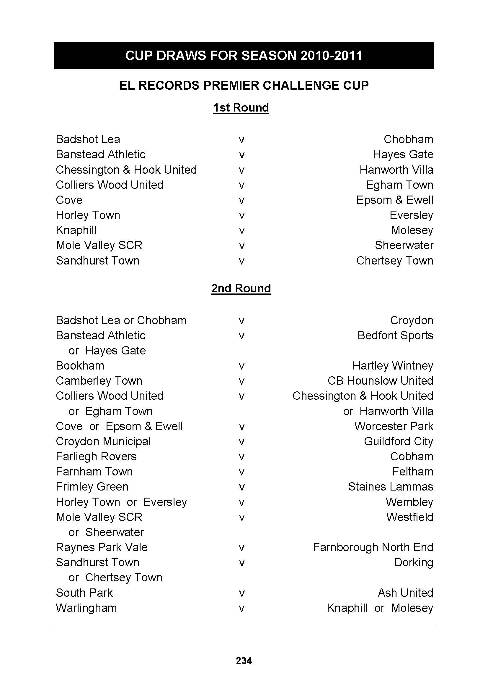

Player Sponsorship
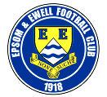 |   Shirts (£25.00) |   Shorts (£12.00) |   Socks (£8.00)
The cost is shown by each item, or you can sponsor
a player for £40.00. Speak to Tony Jeffcoate.

Ramzi Bedj Bedj
Paul Borg
Tony Cuff | Bob Clarke
Matt Fowler

Neil Harrowing

Jamie Hatfield

Ben Hayward
Kyle Hough
Mark Jarman
Tom Jelley
Alex McGregor
Joe Paris
Jamie Reive
Alex Rodrigues
Dean Sammut
Ross Shoefield
Darren Smith | Barry Barnes
Matt Smith
Peter Solomon
Richard Webber
Ben Ward
Charlie West | Paul Norris
Paul West | Paul Smith
Lyndon Buckwell
Tony Coombe
Ken Jones
Barry Barnes

This Season’s Match Sponsors
Fixture | Date | Match Sponsor | Ball Sponsor
Shoreham (F.A. Cup) | 14/08/10 | Epsom & Ewell F.C. Committee
Dorking | 17/08/10 | Pete Beddoe
Mole Vallley SCR | 21/08/10
Flackwell Heath  (F.A. Cup) | 28/08/10 |  | Dick & Dom
Banstead Athletic | 07/09/10
Guildford City | 11/09/10
Ash United | 28/09/10
Molesey | 09/10/10
Badshot Lea | 23/10/10
Raynes Park Vale | 06/11/10
Cove | 20/11/10
Croydon | 04/12/10
Chessington &  Hook United | 11/12/10 | Freeman, Hardy & Willis
For League Matches:

Match sponsorship is available for £35.00.

Match ball sponsorship is available for £20.00.

For Cup Matches:

Match sponsorship is available for £45.00.

Match ball sponsorship is available for £25.00.

Match sponsorship includes admission,
programmes, advertising and hospitality for two.

Match ball sponsorship includes admission,
programme, advertising and hospitality for one.

Interested? Speak to Tony Jeffcoate on 07960 084225 now!

Photo of the week
Gemma Jarman is back with us again, and was in a great position to spot Ramzi Bedj Bedj slotting in the third goal on Wednesday evening at Croydon.
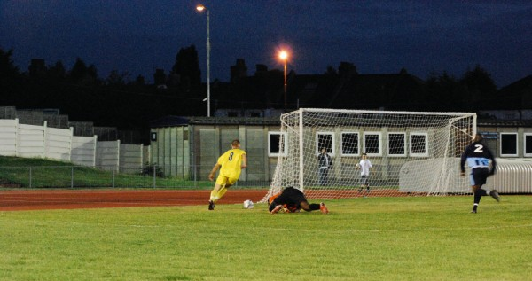

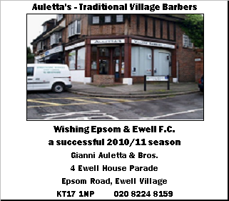

Combined Counties League – Premier Division
Tuesday 17th August 2010 - Kick-off 7.45 p.m.
Epsom and Ewell F.C.  (Royal Blue & White hoops) | V |  |  | Dorking  (Green and White hoops)
Neil Harrowing | 1 |  | 1 | John McBride
Dean Sammut | 2 |  | 2 | David Thompson
Jamie Hatfield | 3 |  | 3 | Sam Sawyers (capt)
(capt) Alex Rodrigues | 4 |  | 4 | Jon Tyler
Charlie West | 5 |  | 5 | Dan Evans
Joe Paris | 6 |  | 6 | Chris Attree
Kyle Hough | 7 |  | 7 | David Suchy
Ramzi Bedj Bedj | 8 |  | 8 | Luke Reid
Mark Jarman | 9 |  | 9 | Andy Miller
Darren Smith | 10 |  | 10 | Harry Maneh
Tony Cuff | 11 |  | 11 | Dean Cox
Tom Jelley | 12 |  | 12 | Tyrone Oliver
Paul Borg | 13 |  | 14 | Toby Fitzgibbon
Chris Read | 14 |  | 15 | Martin Waldren
Matt Fowler | 15 |  | 16 | Leif Borgust
Alex McGregor | 16 |  | 17 | Darryl Jeeves
Lyndon Buckwell | MANAGER |  |  | Adrian Cox
Tony Coombe | ASSISTANT |  |  | Peter Buckland
Barry Barnes | COACH |  |  | John Badillo
Ken Jones | PHYSIO
REFEREE: R.Simon (Hounslow)
ASSISTANT REFEREES: I.Hempel (Chessington), P.Brooks (Forest Hill)
Today’s Match Sponsor is
our Vice-Chairman Pete Beddoe

OUR NEXT FIRST TEAM MATCH AT MOATSIDE

Epsom and Ewell v Mole Valley SCR

Saturday 21st August - Kick-off 3.00 p.m.

Combined Counties League - Premier Division

